

MES Traceability Solution

Cyient Limited

Project ID:
Software Requirement Specification (SRS)
BAR CODE INDIA, 145 Udyog Vihar Phase 1, Gurugram, Haryana-122016, PH: 0124 4337555

Prepared By: Prateeksha
Submission Date: 05-Apr-2023
Version: 1.0.0
The document details the summary of solution architecture and approach for the development of MES Traceability System for Cyient. The document is based on the inputs, system study, discussions and meeting held between BCI & Cyient Teams.

REVISION NO. | DATE | PREPARED BY | REVIEWED BY | COMMENT
1.0.0 | 04-05-2023 | Prateeksha | Gagan Mittal | Software Requirement Specification document for Cyient MES Traceability Solution.
  - REVISION HISTORY

Abbreviations:
Client: Cyient Limited, henceforth will be referred as Cyient.
Vendor: Bar Code India, henceforth, will be referred as BCI.
Notice:
This document contains information, which is the proprietary property of Bar Code India. This document is received in confidence and its contents cannot be disclosed or copied without the prior written consent of Bar Code India.

Nothing in this document constitutes a guaranty, warranty, or license, express or implied. Bar Code India disclaims all liability for all such guaranties, warranties, and licenses, including but not limited to: Fitness for a particular purpose; merchantability; not infringement of intellectual property or other rights of any third party or of Bar Code India; indemnity; and all others. The reader is advised that third parties can have intellectual property rights that can be relevant to this document and the technologies discussed herein and are advised to seek the advice of competent legal counsel, without obligation of Bar Code India.

Bar Code India retains the right to make changes to this document at any time, without notice. Bar Code India makes no warranty for the use of this document and assumes no responsibility for any errors that can appear in the document nor does it make a commitment to update the information contained herein.

COPYRIGHT
Copyright © BCI 2023. All rights reserved.
TRADEMARKS
*Other product and corporate names may be trademarks of other companies and are used only for explanation and to the owners' benefit, wsithout intent to infringe.
  - Table of Contents
1 Specification Organization 1
2 Introduction 2
2.1 Intended Audience and Reading Suggestions 2
2.2 Project Scope 3
3 Software/Hardware Requirements 4
3.1 Central Server configuration/ Database Servers 4
3.2 Desktop Computers 4
3.3 Hardware Requirements 4
4 Solution Architecture 5
5 User Interface Specification Conventions 6
6 System Log 7
6.1 Error Logs 7
7 Architectural Design 8
7.1 SAP Interface 8
7.2 Machine Integration with API 8
7.3 Scheduler Application 8
7.4 Web Application 8
7.5 Android Device Application 8
8 Application Modules 9
8.1 Application Login 9
8.2 User Management & Master Data 11
8.2.1 User Master 11
8.2.2 Group Master 12
8.2.3 Group Rights 12
8.3 Master Data 14
8.3.1 Material Master 14
8.3.2 BOM Master 16
8.3.3 SAP Location Master 18
8.3.4 Physical Location Master 19
8.3.5 QC Sampling Master 20
8.3.6 Checklist Master 23
8.3.7 Model Master 33
8.3.8 Tool Master 34
8.3.9 Machine Master 35
8.3.10 Program Master 37
8.3.11 Route Master 37
8.4 RM Store Operations 39
8.4.1 Process at Glance 39
8.4.2 Receiving & Label Printing 40
8.4.3 Quality Checking 43
8.4.4 Putaway 46
8.4.5 Issue To Shop Floor 48
8.4.6 Supplier Return 50
8.4.7 Job Work 52
8.4.8 Material Return From Shop Floor (MRN) 54
8.4.9 SFG Return to RM Warehouse 56
8.4.10 Stock Take 58
8.5 WIP Operations-SMT Line 62
8.5.1 Process at a Glance 62
8.5.2 Solder Paste Storage 63
8.5.3 Solder Paste Mixing 65
8.5.4 Material Issuance at Line 67
8.5.5 PCB Label Printing 69
8.5.6 Loading & Cleaning 71
8.5.7 Solder Paste Printing 72
8.5.8 Solder Paste Printing Inspection 74
8.5.9 Pick & Place Machine 1 76
8.5.10 Pick & Place Machine 2 78
8.5.11 Reflow Oven 80
8.5.12 AOI (Automated Inspection) 82
8.5.13 X Ray Machine Inspection 84
8.5.14 Rework 86
8.6 WIP Operations-Assembly Line 88
8.6.1 Process at a Glance 88
8.6.2 Model Wise MAC ID Upload 89
8.6.3 Mac ID-Production Order Mapping 91
8.6.4 RF Testing Calibration 93
8.6.5 CPE Label Printing 95
8.6.6 Testing- BOB, Functional, Flow, Optical/ Final Test Calibration 97
8.6.7 Gift Box Label Printing 100
8.6.8 Carton Label Printing 102
8.6.9 Final Quality Check (FGQC) 105
8.6.10 Bin Replenishment 108
8.7 FG Warehouse Operations 109
8.7.1 Process at a Glance 109
8.7.2 Putaway 110
8.7.3 Picklist Generation 111
8.7.4 Picking 113
8.7.5 PDI Inspection 115
8.7.6 Loading & Dispatch 118
8.7.7 Sales Return 119
8.7.8 RMA Repair 121
8.8 Internal Movement 122
8.9 Firmware Upgradation 123
8.10 Reports 125
9 SAP Integration Touch Points 127
10 SRS Scope Change Process 130
10.1 Before Sign Off 130
10.2 After Sign Off 130
10.3 SRS Acceptance 130

Specification Organization
The objective of this document is to supply underlying concepts, procedures, and formats used in the design, development and installation of this software application. This specification consists of three sections organized as follows:
Section 1: Introduction

This section provides hardware requirements and documentation conventions.

Section 2: User Interface

This section depicts screen design and logic flow, and is categorized into two groups:
- Application Function Module
- Common Routine

Section 3: System Architecture
This section provides information of system architecture.

Introduction

Intended Audience and Reading Suggestions
The scope of this document is to provide the understanding of this solution to user & development teams associated with the application development & implementation.
This document major emphasizes on providing clear understanding of MES Traceability System.
This solution comprises of:
- Web Application
- Android Device Application
- Scheduler Application
- SAP Integration (API Interface)
- Machine Integration with API

Project Scope
The project scope is the development and implementation of Warehouse Management System using AIDC Technology (Barcode Labels, Mobile Computers) to efficiently automate the Warehouse and Shop Floor operations.
The solution will be developed for RM Warehouse, Production Unit and FG Warehouse.
Warehouse: The application will automate the warehouse operations i.e. Receiving, Putaway and Issuing of raw material. The Items will be received against GRN fetched from SAP and unique identification will be provided by printing barcode labels for them in case of non-barcoded material. The material will be sent for Quality Checking which will be done as per the Sampling Plan; based on Quality Status, material will be placed on storage locations. The solution will let user to issue the Items against the Production Order provided from SAP and details will be posted to SAP afterwards.
Shop Floor (Production Unit): This application will provide procedures to keep record and track of material (PCBs, Reels, and Components etc.) when passed from one production stage to another for processing and inspection. The application is required to be integrated with Machines to read the required data at each stage and to update the same in real time. The application will ensures maximum traceability of material used at different stages and prevents any non-conformance from being passed through process.
The application verifies that each PCB must complete previous quality stage before moving for the next stage as per defined route. It also keeps record of the PCBs send for rework process and ensures that user can view the process or inventory details as and when required.
FG Store: The solution streamline and automates all functional areas, including: Receiving, Putaway, Picking, and Dispatch.
This would require development of Wi-Fi enabled application for real time transaction i.e. the data will be captured in real-time, once the data has been collected, the database can then provide useful reports about status of material in warehouse.

Software/Hardware Requirements
Below are the hardware and the software requirements of the application:

Central Server configuration/ Database Servers
The solution would require the high performance server with minimum following:
- Intel Xeon Processor E5-2620 v3 6C 2.4GHz 15MB Cache 85W /16GB 1866MHz TruDDR4 Memory / 2 x 1TB 2.5in 7.2K RPM SAS SFF Hot Swap/ Server AID M5210 SAS/SATA Controller MULTIBURNER DVD System x 550W
- Windows 2008 server or above
- MS SQL Standard

Desktop Computers
Desktop would require following specifications:-
- I5/i7 Processor with Windows 10 Operating System
- 8 GB RAM
- 100GB HDD
- Dot net Framework 4.5

Hardware Requirements
Hardware required for the application:
- Barcode Printer ZT411-300dpi
- Device WIFI SCANNER MC2200
- DS4608 Barcode Scanner-USB

Solution Architecture
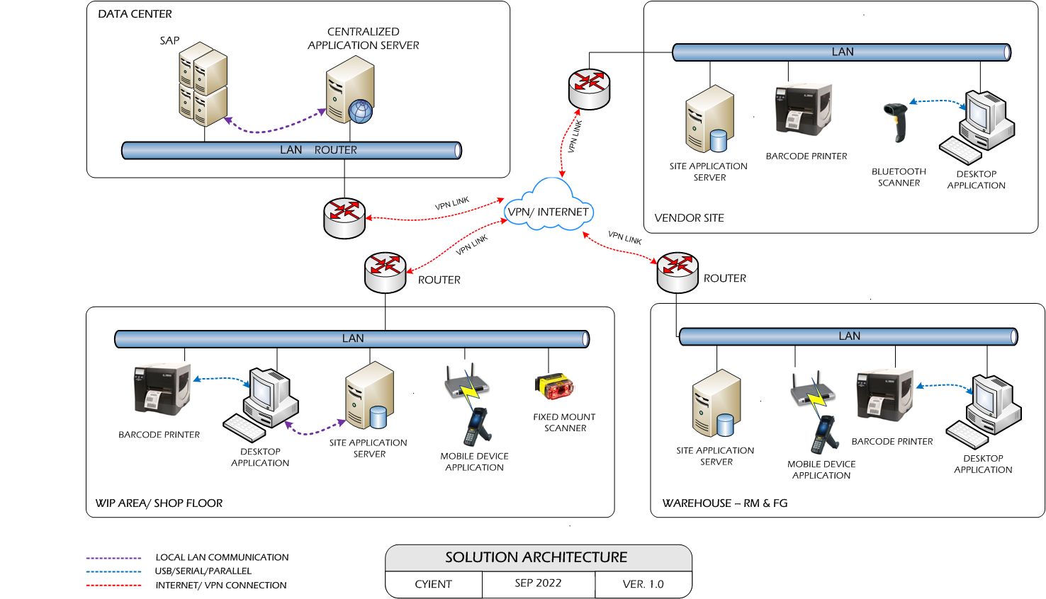

User Interface Specification Conventions
This section specifies the user interface portion of the application.

Section Organization
The User Interface Specification presents screen displays or “Dialogs”.
Documentation Conventions
This section incorporates illustrations of the application user interface. Each screen display “Dialog” consists of the screen display image, a process name, a paragraph documenting the processing required for the dialog, a paragraph listing the navigation options, and a table listing for each variable field on the dialog, its database source or destination, format, and any instructions required to process the field.
The following section contains a sample dialog with each area identified.

System Log
System shall maintain internal logs for application.

Error Logs
These logs will contain any errors encountered during runtime for faster resolution of any problem post deployment.

Architectural Design
Overall System consists of:
- SAP Interface
- Machine Integration with API
- Scheduler Application
- Web Application
- Android Device Application

SAP Interface
SAP Interface (API) will be responsible to sync the data between BCIL database and Client SAP Hana. This interface will be provided by Cyient Team and will be integrated with BCIL application.

Machine Integration with API
This API will be integrated with client’s API to get input and give output for machine integrated processes.

Scheduler Application
Scheduler application will run in background on desktop which will be used to fetch and post the details from/ to SAP Hana.

Web Application
Client Interface application will run on the desktop. To use of application user will create the master data, configuration, quality check and generates the transaction/inventory reports.

Android Device Application
This application will include the entire modules for WIP & WMS processes. Application will directly communication with user input and process the request to communication server.

Application Modules

Application Login
This login module will provide access to the application modules. Here the admin/user needs to enter the login detail to enter in the application and to perform the desired actions.
Process: User needs to enter the User Name/ID and Password in display fields and press the Login button. Application will validate the user credential.
User will be able to view only those screens/ modules of which he has been given access rights to.
Validation
- User Name/ ID will be unique for all users.
- User Name/ ID and Password length will be set.
After successful login application menu screen will appear. Menu screen will have the Master, Label Printing, WIP, DB Settings and Reports options etc.

Login Sample Screen:

User Management & Master Data
The module will let application administrator to manage the Users, and the rights assigned to the same; the rights will define authorized application access of users.

User Master
The module will be used to add, save, delete a particular user details. Admin user will enter details of application’s user. The users will be provided with unique id and password through which they will be able to login to the system.
Data Fields | - Group Code  - Group Name  - User Id  - User Name  - Password  - Confirm Password  - Active/ Inactive
Process Steps | - Admin will select Group Code, Group Name will appear on screen.  - Enter User Id, Username and Password.  - Re-enter Password in Confirm Password.  - Save and Update the details in database.
Functions | Add, Edit/Update, Delete as per requirement
Sample Screen:
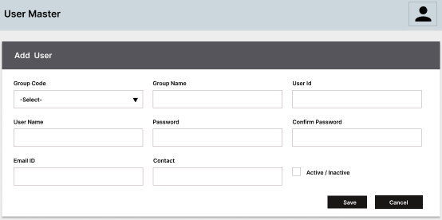

Group Master
This module will help admin user to form groups for application users.
Data Fields | - Group Id  - Group Name  - Active/ Inactive Status
Process Steps | - Admin will enter Group Id and Group Name.  - Select Active Status i.e. Yes/ No.  - Save and Update the details in database.
Functions | Add, Edit/Update, Delete as per requirement
Sample Screen:
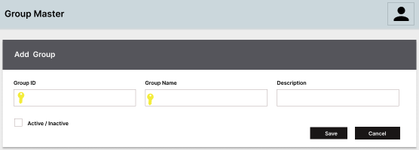

Group Rights
This module will help admin user to assign/ update rights to groups. Once assigned, authorized user groups can access the application forms.
Data Fields | - Group Id  - Group Name  - Module / Form Names
Process Steps | - Admin will select Group Id, Group Name will appear on screen.  - Screen/ module names are displayed in data grid along with checkbox.  - Admin will check the checkbox against module/ screen to which selected group should be assigned access.  - Save and Update the details in database.
Functions | Add, Edit/Update, Delete as per requirement

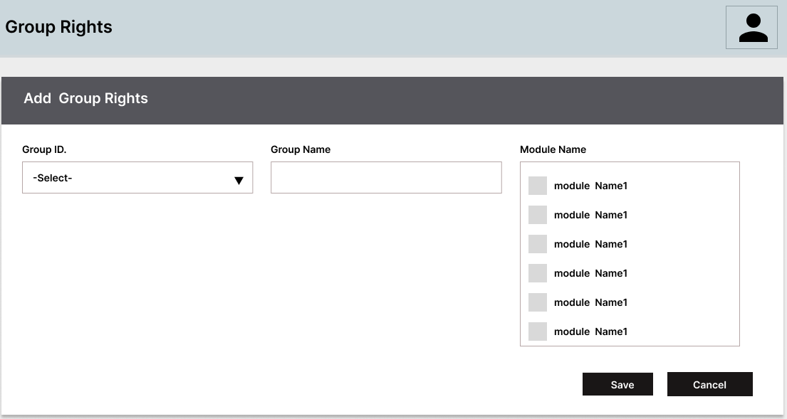
Sample Screen:

Master Data

Material Master
This master will be used to view the material details downloaded from SAP (Hana).
Data Fields | - Site Code  - Item Code,  - Item Name,  - Item Description,  - Item Class- A/ B/C  - Item Category,  - UOM (in Kg/ units only)  - Shelf Life,  - MSD Level,  - Primary Packing Size
Process Steps | - Login into web application and select Material Master  - As soon as module opens, Material details fetched from SAP will appear on screen.
Functions | Import, View
Sample Screens:
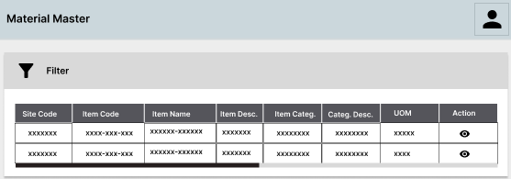

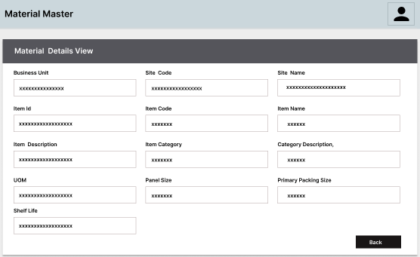

MPN Master
This master will allow user to download the Item wise Manufacturing Part Numbers from SAP via Scheduler.
Data Fields | - Cyient Part Code  - Supplier Part Code  - MPN
Process Steps | - User will open MPN Master.  - Downloaded Item wise MPN details will be displayed on screen.
Functions | View

SAP Location Master
This module will be used to view the SAP Location details used for RM/ WIP/ FG Warehouse fetched from SAP.
Data Fields | - ERP Storage Location Code  - Location Name  - Location Type i.e. RM/ WIP/ FG
Process Steps | - User will open ERP Location Master.  - Downloaded ERP Locations will be displayed on screen.
Functions | View
Sample Screen:
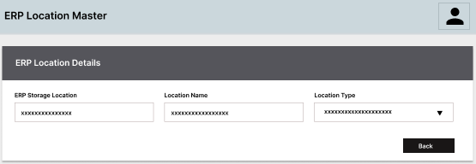

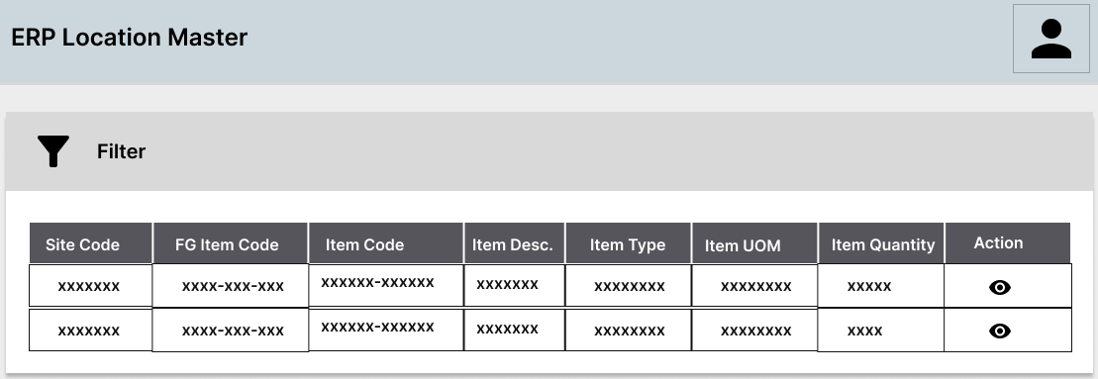

Physical Location Master
The master module will be used to save the physical storage location details and print the location barcode label for same.
Data Fields | - Storage Location Code  - Location Area – RM/ WIP/ FG  - Location Category- Ok/ Reject/ On Hold/ Under QC  - Material Part Code
Process Steps | - Enter Location ID, Description.  - Select Location Category i.e. Ok/ Reject/ On Hold/ Scrap.  - Select Storage Location Name.  - Click on Save.  - Print label for location.  - Paste label on location.  - Newly added Location details will appear on screen in data grid
Functions | Add, Edit/Update, Delete as per requirement
Sample Screen:
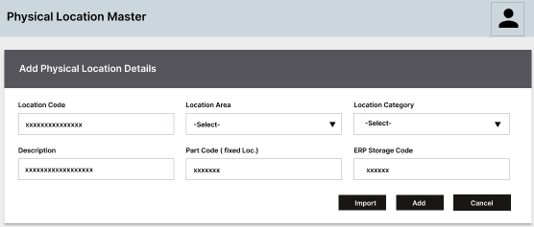

Part Wise Customer Mapping Master
This master will be used to map FG Item code with Customer Part and save the mapping details in database. Master will contain Item Code, Customer Part Code, and Description etc.

IQC Sampling Master
This module will allow user to create QC Sampling Plan for RM/ WIP/ FG against Material Type in order to perform inspection as per Lot Quantity; corresponding details are saved in database
Data Fields | - Item Class A/ B/C,  - Lot Quantity  - Inspection Quantity
Process Steps | - Select Item Class- A/ B/ C.  - Enter Lot Quantity.  - Enter Inspection Quantity  - Click on Save.  - Newly added Sampling Plan details will appear on screen in data grid
Functions | Add, Edit/Update, Delete as per requirement
Sampling Plans:
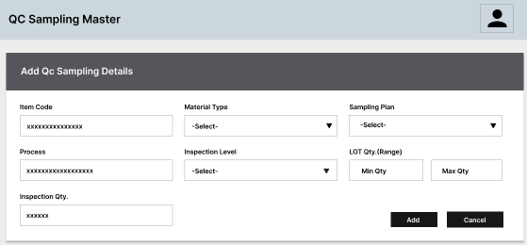

Checklist Master
This module will allow user to save Checklist parameters details for quality purpose. User will be able to edit, delete the checklist details as per requirement.
Data Fields | - Checkpoint  - Observation  - Item  - Stage  - Work Order Number  - Model Number  - Sample Size  - Rejection Type Operator  - Offer Quantity,  - OK Quantity,  - NG Quantity
Process Steps | - User will enter Checkpoint Name.  - Enter/ select Work Order Number, Model Number, Sample Size, Item, Stage, etc. as per requirement.  - Click on Save.  - Newly added Checklist details will appear on screen in data grid
Functions | Add, Edit/Update, Delete as per requirement
Sample Screen:
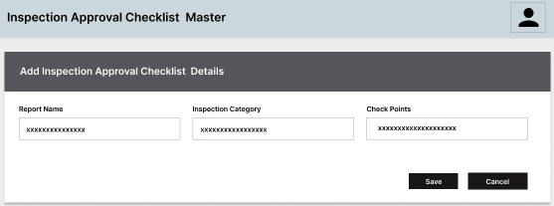

Model Master
The user will create Model Master to store model details like Model Number, description, RSN, EAN code, color code, Carton Packsize, etc. The labels will be printed for the Cartons & Pallets as per the Packsize defined in Master.
Data Fields | - Model Number  - Model Description  - RSN  - EAN code  - Color code  - Carton Packsize
Process Steps | - Enter Model Number, Description, RSN.  - Enter Carton Size.  - Click on Save.  - Model details will appear on screen in data grid
Functions | Add, Edit/Update, Delete as per requirement
Requirement: | Sample data needs to be shared by Cyient in case Model Master need to be added separately for adding model related information.
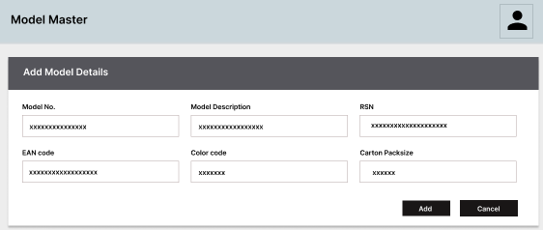
Sample Screen:

Tool Master
This master will be used to store tools details in database. Using this master, Tool barcode label will be printed to provide unique identification to each tool. User can add, edit and delete tool details, if required. Tools could be Stencil, Feeder etc.
Data Fields | - Tool Id  - Tool Type  - Tool Description  - Shelf Life (in No. of PCBs)
Process Steps | - Enter Tool Id, Description, Shelf Life, etc.  - Select Tool Type.  - Click on Save.  - Print label for Tool.  - Paste label on tool.  - Newly added Tool details will appear on screen in data grid
Functions | Add, Edit/Update, Delete as per requirement
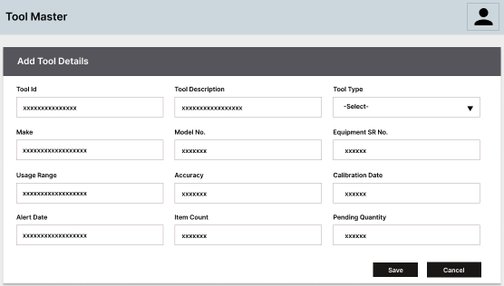
Sample Screen:

Machine Master
This master will be used to store machine/ workstation details in database. In this Master, user will also define where set check point duration will be implied on Machine and at what stage. Using this master, user will print the barcode label to provide unique identification to each machine/ workstation in plant.
Data Fields | - Machine/ Workstation ID  - Machine Type  - Model  - Description  - Stage
Process Steps | - Enter Machine/ Workstation ID, Description, Model, etc.  - Select Machine Type.  - Select Stage.  - Click on Save.  - Print label for Machine.  - Paste label on Machine.  - Newly added Machine details will appear on screen in data grid
Functions | Add, Edit/Update, Delete as per requirement
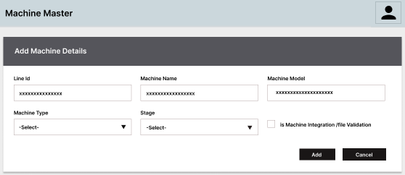
Sample Screen:

Process Master
This master will be used to store process to be followed during PCB processing at production line. Each program will be mapped with Machine and FG Item to be produced.
Process ID will help user to validate the Components being issued to SMT/ Assembly Station w.r.t FG Item Code i.e. the system will check whether the Items like Reels/ Tools/ Components are issued at the right station against the FG Item Code selected, if not, then an alert will be displayed to user at the time of processing.
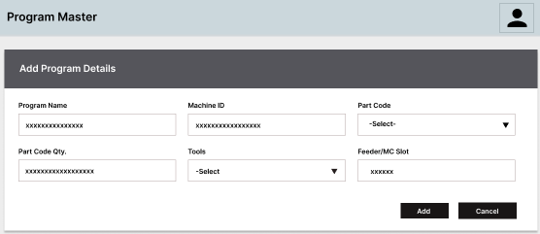
Sample Screen:

Route Master
This master will be used to define the production stages /processes which should be followed by Model for processing. Using this master, each Model will be mapped with the Stages/ Processes associated with it. User will select the Model and respective Stages/Processes. The mapping will get saved in database and will be used at the time of validating Model during production process.
Data Fields | - FG Item Code  - Model  - Stage/ Process Name  - Route Sequence  - Rework Sequence
Process Steps | - User will select the FG Item Code/ Model and respective Stages/Processes.  - Enter/ Select Route Sequence Number for the Stage.  - Select Rework Sequence.  - Click on Save.  - Newly added Route details will appear on screen in data grid
Functions | Add, Edit/Update, Delete as per requirement
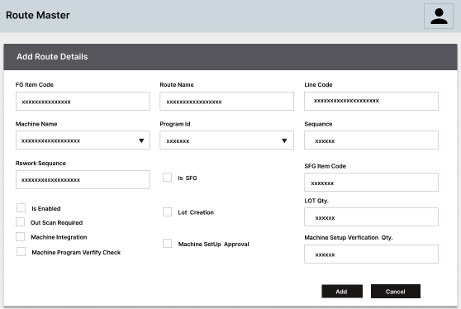
Sample Screen:

NOTE:
Label Design for the complete RM, WIP Process will be created by Cyient and the PRN file for the same will be shared with BCI.

Email Master
This master will be used to save email details against a Process/ Program in database. User can edit or delete the details as per requirement.
Data Fields | - Process Id  - Process Name  - Mail Subject  - Mail Body  - From Mail Id  - To Mail Id  - SMTP Detail  - User Id  - Password  - Active/ Inactive
Process Steps | - User will select the FG Item Code/ Model and respective Stages/Processes.  - Enter/ Select Route Sequence Number for the Stage.  - Select Rework Sequence.  - Click on Save.  - Newly added Route details will appear on screen in data grid
Functions | Add, Edit/Update, Delete as per requirement

Defect Master
This master will be used to define the defect against a Process/ Stage in database. User can edit or delete the details as per requirement.
Data Fields | - Process Id  - Process Name  - Defect Description  - Active/ Inactive
Process Steps | - User will select the Process Id, Process Name will appear on screen.  - Enter Defect Description.  - Select Active/ Inactive as Yes/ No to make defect active or inactive.  - Click on Save.  - Newly added Defect details will appear on screen in data grid
Functions | Add, Edit/Update, Delete as per requirement

RM Store Operations

Process at Glance
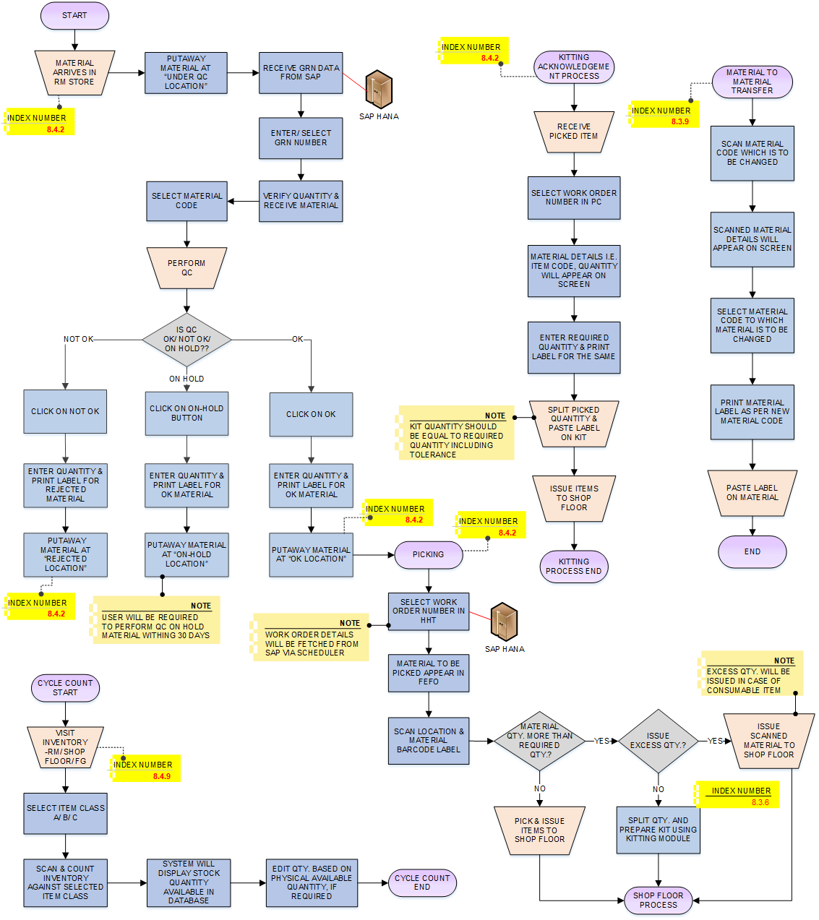

Receiving & Quality Check
Activities
Module Description | In this process, material will be received from Supplier/ Vendor against GRN. QC person will check quality of received material and barcode labels will be printed for the material. The module will help in printing Item barcode label and updating received stock details in database.  *This module will run in Device Application.

Pre-Conditions | - GRN details should be fetched from SAP Hana.  - Scheduler application should be running in background to fetch GRN details.  - Material should have barcode label in uniform nomenclature.  - Printer should be connected with the application (in vase of non-barcode material).

Process Steps | - Material received at warehouse  - Select GRN No from dropdown.  *GRN details will be fetched from SAP via Scheduler.  - Material details such as Material Code, Description, Quantity, etc. against selected GRN will be displayed on the screen.  - Select Material Code against sampling quantity from dropdown.  - Check Quality against Sampling Quantity.  - If Quality is “OK”:  - Click on “OK”.  - Enter quantity  - Print label for Ok material.  - Move material for putaway at OK location.  *Whole GRN quantity will be accepted.  - If Quality is “Not OK”:  - Click on “Not OK”.  - Enter quantity  - Print label for rejected material.  - Move material to Rejected location  *Whole GRN quantity will be rejected.  - If Quality is “On Hold”:  - Click on “On Hold”.  - Enter quantity  - Print label for On Hold material.  - Move material for putaway at On Hold location.  *User will be notified via Email to perform QC on On-Hold material within 30 days.  - Details will get updated in database.

Post-Conditions | - Inventory details should get updated.  - OK Material will be sent for Putaway on OK Type storage locations; Not Ok material will move to Not OK whereas On Hold will move for putaway at On Location.  - QC should be performed on On-Hold location within 30 days.

Validations | - Only authorized users should be allowed to access the application else an error message should be displayed on screen.  - An alert message is displayed in case of any error / invalid activity.  - An alert should be displayed in case no GRN is available

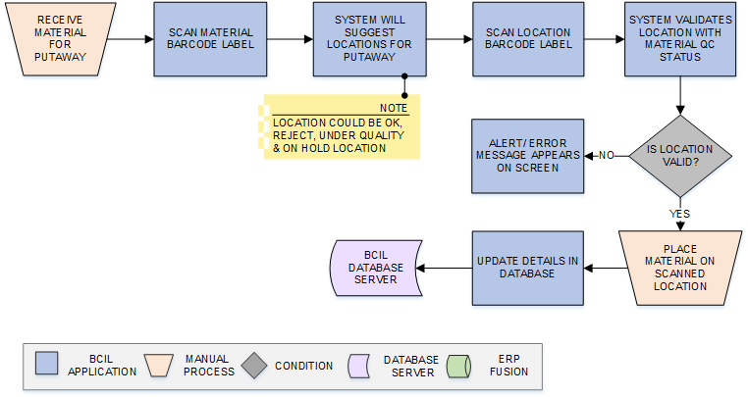
Putaway
Activities
Module Description | The module will help user to scan and place the raw material at storage locations (or in Bins) of Warehouse suggested by system and update the corresponding location-material mapping details in database.  *The module will run on Android Device.

Pre-Conditions | - Material should have barcode label.  - Location label printing and pasting should have been done via Location Master.  - Quality checking of material should have been completed.  - HHT Device should be available.

Process Steps | - Material are received for Putaway.  - Scan Material Barcode label.  - System will suggest the Location based on the QC Status and Material Code.  - Scan Location Barcode label.  - System will validate scanned Location and material.  - If scanned Location is Valid:  - Place material on scanned Location.  - If scanned Location is Valid:  - An alert message will be displayed.  - Material Location mapping details will be updated in database.

Post-Conditions | - Location-material mapping details should get updated in database.

Validations | - An alert should be displayed in case invalid/ duplicate material barcode is scanned.  - An alert should be displayed in case invalid/ duplicate Location barcode is scanned.  - An alert message should be displayed in case Location scanned is not as per the Material Quality.  - An alert should be displayed in case user tries to place multiple Item Code on a single location.  *One location cannot have multiple Item Code.

Picking and Issuance
Activities
Module Description | The module will help user to pick requested items from suggested location and verify the item against picklist. Then the Material/Kit will be issued to Shop Floor from RM Warehouse. Details will get updated in database.  **This module will run in Device Application.

Pre-Conditions | - POST API will be required to send issuance details into SAP for inventory update.  - API/ Web Service Interface for ERP Integration will be provided by Cyient  - HHT Device should be available

Process Steps | - Select Work Order Number.  *Work Order will be fetched from SAP via Scheduler on set time interval.  - Material Code, Quantity etc. details appear on screen  - Select Material from data grid.  - System will display locations for selected material picking.  *System will suggest location for picking on First Expire First Out basis. FEFO function can be enable and disable.  - Scan Location Barcode Label  - Scan Material Barcode Label against Work Order  - System will check if scanned material quantity is more than pick quantity  a. Excess Issue: Pick and Issue scanned material to WIP area  b. Partial Issue: Pick material and Split quantity using Kitting module.  - Click on Save /Confirm Picking, system will check whether Work Order is complete  a. Work Order Complete: Details are saved in database  b. Work Order not complete: Confirmation message displayed to save partial work order picking.  - Corresponding details will get updated in database

Post-Conditions | - Transaction details are saved in database  - System will validate location and material barcode label while scanning.  - System will suggest items for picking in FIFO order.  - System will enforce FEFO for material picking.  - System will check whether material quantity is more than pick quantity. If yes, system will allow user to issue excess material or split quantity using Kitting module.  - In case of partial issuance, kitting module will be used to split the material quantity; system must update the remaining quantity of material; printing of barcode label for leftover quantity is done via Kitting module.  - System will allow user to save partial work order picking.  - System should update the RM inventory quantity accordingly

Validations | - System will validate input data i.e. text field values and selections.  - BCI Scheduler will download Work Order from SAP on set time intervals; In case Scheduler is unable to fetch the data, an alert or error message should be displayed to user.  - An alert message will be displayed in case of invalid / duplicate barcode.  - An alert message is displayed in case of any error / invalid activity.  - Scanned material and quantity will be validated against selected Work Order.  - System will display error/ alert message in case any invalid/duplicate Material barcode is scanned.  - System will display error/ alert message in case any invalid/duplicate Location barcode is scanned.  - System will display error/ alert message in case any invalid material is picked.

Material to Material Transfer
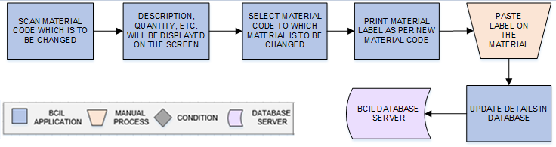
Activities
Module Description | The module will help user to transfer one material code to another material code and save the details in the database.  *This activity will be performed via Web application.

Pre-Conditions | - Material code to which material is to be changes should be available  - Material master should be available.

Process Steps | - Scan Material Code which is to be changed.  - Scanned material details such as Description, Quantity, etc. will be displayed on the screen.  - Select Material Code to which material is to be changed.  - Click on Print button to print material label as per new material code.  - Paste label on the material.  - Details will get updated in database.

Post-Conditions | - Transaction details are saved in database  - Material Code will be changed as per requirement.

Validations | - An alert message will be displayed in case of invalid / duplicate Material code is scanned.

Kitting Acknowledgment Process
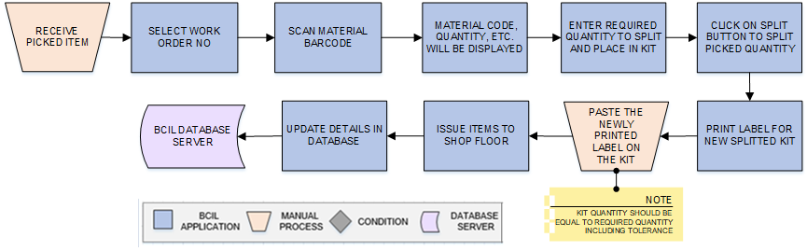
Activities
Module Description | This module will be split material quantity for Kit and to print barcode labels for split quantity; the remaining material quantity will be updated. Details for the same will be updated in database.  *This activity will be performed via Device Application.

Pre-Conditions | - Material should have barcode label.  - Quality checking of material should have been completed.  - HHT Device should be available.

Process Steps | - Receive Picked Item.  - Select Work Order No from dropdown.  - Scan material barcode.  - Material details such as Item Code, Quantity, etc. will be displayed on the screen.  - Enter required quantity to split and place in Kit.  - Click on Split button to split picked quantity.  - Print label for the entered quantity.  - Paste the newly printed label on the Kit.  *Kit quantity should be equal to required quantity including tolerance.  - Issue items to shop floor.  - Details will get updated in database.

Post-Conditions | - Once Kitting is done, Kit is scanned and issued to WIP Area.  - Remaining Material quantity should be updated.  - Putaway the remaining material back to its location

Validations | - An alert message will be displayed in case of invalid / duplicate barcode is scanned.  - An alert message is displayed in case of any error / invalid activity.

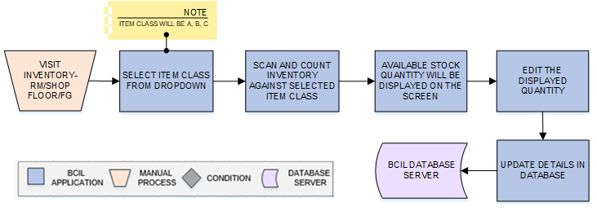
Cycle count
Activities
Module Description | The module will help user to count the material quantity and details will get updated in database.  *This activity will be performed via Desktop application.

Pre-Conditions | - Available stock quantity should be available.

Process Steps | - Visit Inventory-RM/Shop Floor/FG.  - Select item class from dropdown.  *Item class will be A, B, C.  - Scan and count inventory against selected item class.  - Available stock quantity will be displayed on the screen.  - Edit the displayed quantity based on physical available quantity as per requirement.  - Details will be updated in database.

Post-Conditions | - Transaction details are saved in database

Validations | - An alert message will be displayed in case of Item class is not available in dropdown list.  - An alert message is displayed in case of any error / invalid activity.

WIP Operations-SMT Line

Process at a Glance

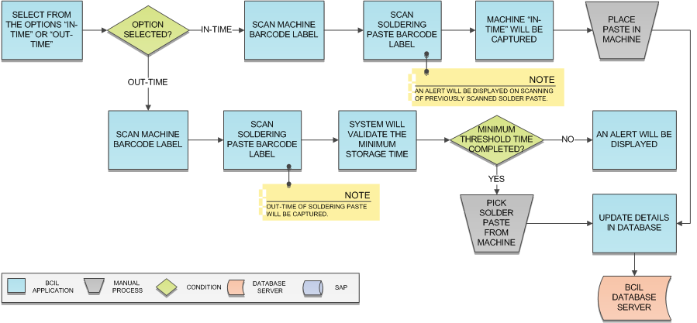
Solder Paste Storage
Activities
Module Description | This module will be used to capture the Soldering Paste storage In and Out Time; the Paste will be placed in refrigerators for the defined period of time, user will be notified in case Paste is moved out from refrigerator before the defined or set time interval.  *This module will run on Android Device.

Pre-Conditions | - Refrigerator Barcode should be printed via Machine Identification module.  - Solder Paste should have Barcode Label.

Process Steps | - Select from the option "In-Time" or "Out-Time".  - "In-Time" selected:  - Scan Machine (Refrigerator) barcode label.  - Scan Soldering Paste barcode label.  *System will display an alert if previously scanned or partially consumed Soldering Paste is being scanned.  - Soldering Paste refrigerator "In-Time" will be captured and updated.  - "Out-Time" selected:  - Scan Machine barcode label.  - Scan Soldering Paste barcode label.  - System will check whether Soldering Paste have been in refrigeration till minimum threshold time:  - Threshold Time Completed: Out Time will be captured.  - Time not completed: An alert will be displayed to user.  - Process details i.e. Soldering Paste In and Out Time along with Machine will be updated in database.

Post-Conditions | - Solder Paste should be taken out of refrigerator and move for Mixing.

Validations | - An alert message is displayed in case invalid or duplicate barcode is scanned.  - System will check whether Soldering Paste previous process has been completed on Paste scanning at In-Time.  - Soldering Paste minimum threshold time should be completed before removing Paste from Machine.  - An alert should be displayed when removing Soldering Paste before threshold time completion.

Solder Paste Mixing
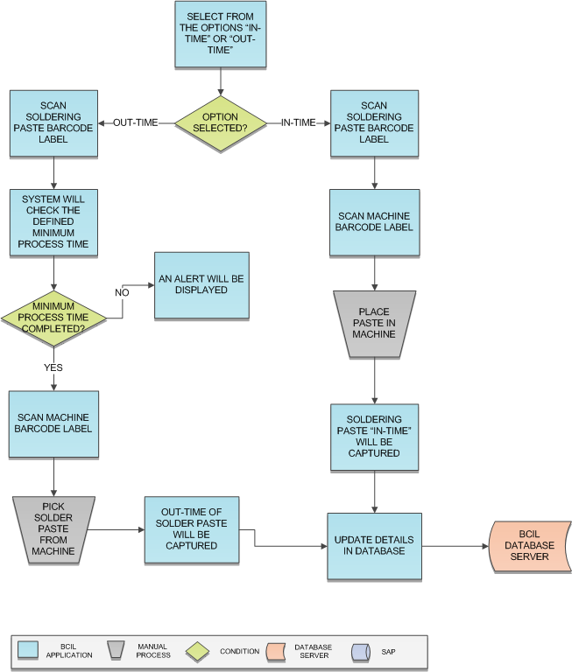

Activities
Module Description | This module will be used to capture the Soldering Paste storage In and Out Time; the Paste will be placed in refrigerators for the defined period of time, user will be notified in case Paste is moved out from refrigerator before the defined or set time interval.  *This module will run on Android Device.

Pre-Conditions | - Mixing Machine should have barcode label.  - Solder Paste should have Barcode Label.  - Solder Paste have been issued via Solder Paste Issuance module.

Process Steps | - Select from the option "In-Time" or "Out-Time".  - "In-Time" selected:  - Scan Machine (Refrigerator) barcode label.  - Scan Soldering Paste barcode label.  *System will display an alert if previously scanned or partially consumed Soldering Paste is being scanned.  - Soldering Paste refrigerator "In-Time" will be captured and updated.  - "Out-Time" selected:  - Scan Machine barcode label.  - Scan Soldering Paste barcode label.  - System will check whether Soldering Paste have been in refrigeration till minimum threshold time:  - Threshold Time Completed: Out Time will be captured.  - Time not completed: An alert will be displayed to user.  - Process details i.e. Soldering Paste In and Out Time along with Machine will be updated in database.

Material Issuance at Line
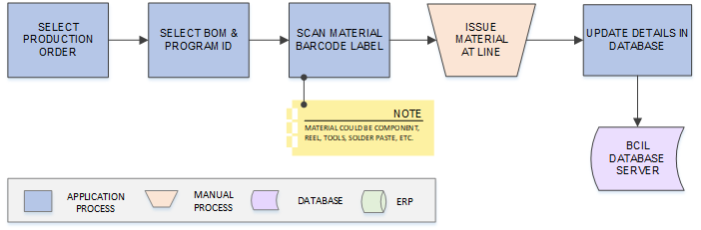
Activities
Module Description | This module will be used to issue the material (Component, Reel, Tools, Solder Paste, etc.) at Production Line against BOM and Program Id w.r.t. selected Production Order and update corresponding details in database.  *This module will run on Android Device.

Pre-Conditions | - Solder Paste Mixing has been done.  - Production Order should be available.  - BOM details should be available  - Program details should be maintained in Program Master

Process Steps | - User will select Production Order.  - Select BOM, Program Id  - Scan Material Barcode Label (Component, Reel, Tools, Solder Paste, etc.) against selected Production Order.  - Issue scanned material at Line.  - Save details in the database.

Post-Conditions | - Issued material should be moved to WIP Area/ Shop Floor.  - Issued material quantity will get reduced and RM inventory gets updated.

Validations | - An alert should be displayed in case Production Plan is not available.  - An alert should be displayed in case duplicate/ invalid barcode is scanned.  - An alert should be displayed in case wrong material is scanned for Issuance.

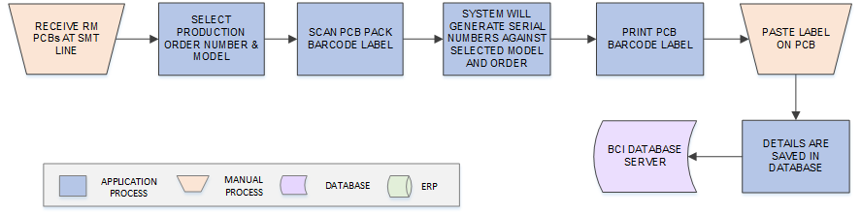
PCB Label Printing
Activities
Module Description | The module will let user to print barcode labels for the PCBs, each PCB will have a unique serial number.  *This activity will be performed via Web Application.

Pre-Conditions | - Machine should have barcode label.  - PCB should have Barcode Label.  - Interface will be required to fetch Production Order.  - Printer should be connected with the application.

Process Steps | - Select the Production Order Number.  - User will select the Model Number.  - Production Order details will be displayed to user.  - User will scan the PCB’s pack barcode label.  - PCB Pack Quantity will be displayed to user.  - User will print the barcode labels for PCBs.  - Paste barcode label on PCBs.  - Save the details in database.

Post-Conditions | - PCBs will move for next process.

Validations | - An alert should be displayed in case Production Plan is not available.  - A unique Running Serial should get printed on the PCB label.  - An alert should get displayed in case printer is not connected or a label is not printed.

Loading & Cleaning
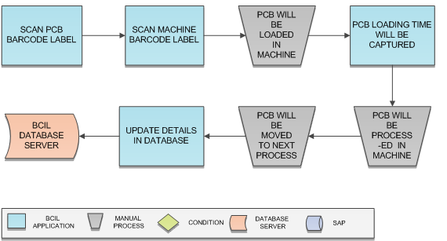

Activities
Module Description | The module will be used to update the PCB process details and capture the PCBs In &Out Time; PCBs will be scanned at the time of process in & at process completion.  *This activity will be performed via Device Application.

Pre-Conditions | - Machine should have barcode label.  - PCB should have Barcode Label.

Process Steps | - User will scan PCB barcode label.  - Scan Machine barcode label.  - PCB will be loaded in the Machine.  - PCB Loading Time will be captured.  - PCB will be processed in Machine and will be moved to next process via conveyor.  - Details will be saved in database.

Post-Conditions | - PCB will move for next process at Conveyor.

Validations | - PCB In Time should get updated as PCB is scanned at process beginning.  - An alert should get displayed in case PCB is not scanned at In Time.

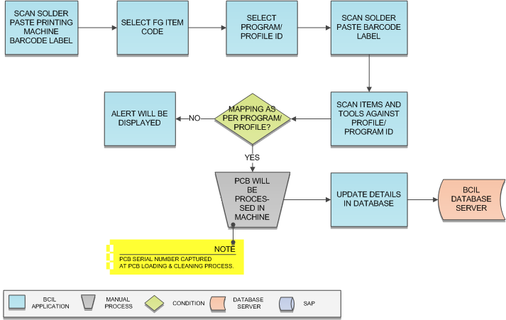
Solder Paste Printing
Activities
Module Description | The module will be used to update the Solder Paste & PCB printing process; system will capture the Tools, Components and Soldering Paste used in the process.  *This activity will be performed via Device Application.

Pre-Conditions | - Machine should have barcode label.  - PCB Pack should have Barcode Label.  - Solder Paste should have barcode label.  - Program details should have saved in Program Master.  - Stencil should not have exceeded its Shelf Life.

Process Steps | - User will scan the Solder Paste Printing Machine barcode label.  - Select FG Item Code.  - Select the Profile/ Program ID.  - Scan the Solder Paste barcode label.  - Scan the Items and Tools against the Profile/ Program ID.  - System will verify the mapped Solder Paste, Items and Tools as per Profile/ Program ID for the Machine  - Mapping “OK”: PCB will be processed in Machine.  *PCB Serial Number captured at the time of PCB Loading & Cleaning.  - Mapping “Not OK”: An alert will be displayed.  - PCB will be moved out via conveyor.  - Process details will be updated in database.

Post-Conditions | - PCB will move for Solder Paste Inspection.

Validations | - Scanned Solder Paste Printing Machine, Solder Paste, Items and Tools will be checked against the mapping updated in Program Master data, if mapping is invalid, an alert will be displayed on scanning.  - In-Time of PCB at Solder Paste Printing Inspection process will be the Out-Time of PCB at Solder Paste Printer Machine.

Solder Paste Printing Inspection
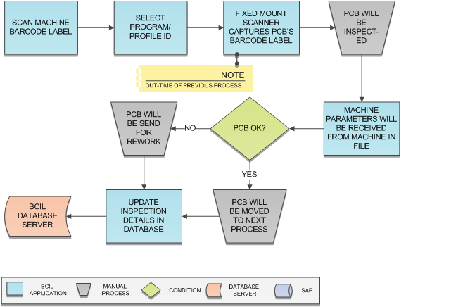
Activities
Module Description | The module will be used to update the PCB inspection details; PCBs In Time will be captured via Fixed Mount Scanner and the time stamp will be updated in the database.  *This activity will be performed via Device Application.

Pre-Conditions | - Machine should have barcode label.  - PCB Pack should have Barcode Label.  - Solder Paste Printing should have been done.  - Fixed Mount Scanner (FMS) should be integrated with the application.  *Fixed Mount Scanner and Machine Integration at SMT Line needs to be discussed with Cyient Team.  - Program details should have saved in Program Master.

Process Steps | - User will scan Machine barcode label.  - Select Program/ Profile ID.  - PCB process In-Time will be displayed on screen.  *Fixed Mount Scanner on conveyor has scanned PCB at the time of PCB- IN.  - PCB will be inspected.  - If defect found, PCB will be auto rejected by Machine; status for same will be updated.  - Rework Station Id will be selected, and PCB will be moved to Rework.  - Machine will provide inspection parameters in file.  - Fixed Mount Scanner will capture the “OK” PCB’s Out-Time and same will get updated in database.

Post-Conditions | - PCBs will be moved to the next process through conveyor movement.  - Defected PCBs will be moved for Rework.  - Parameter files will be received from Machine and saved in a defined folder from where system will check for PCB result.

Validations | - System will validate whether PCB In-Time is captured by Fixed Mount Scanner & updated in database.  - PCB Inspection status should get updated in a file and file should be available in shared file.

Pick & Place Machine 1
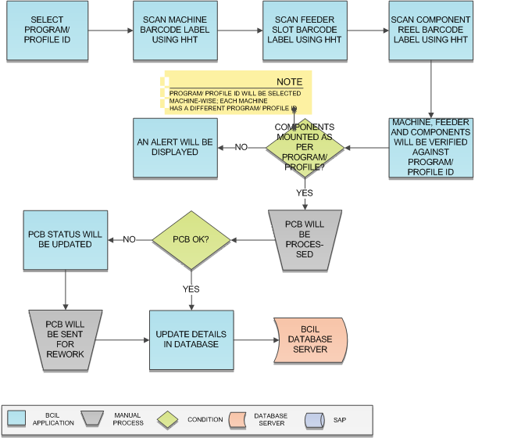
Activities
Module Description | The module will be used to update the details of Components that will be mounted on the PCBs; user will map the Machine, Feeder and Components which will be used in processing; system will validate whether the modules are as per Profile/ Program ID.  *This activity will be performed via Device Application.

Pre-Conditions | - Machine should have barcode label.  - PCB Pack should have Barcode Label.  - Solder Paste Printing Inspection should have been done.  - Fixed Mount Scanner (FMS) should be integrated with the application.  *Fixed Mount Scanner and Machine Integration at SMT Line needs to be discussed with Cyient Team.  - Program details should have saved in Program Master.  - PCB serial number should be captured at beginning of Solder Paste Printing Inspection screen.

Process Steps | - User will scan Machine barcode label.  - Select Program/ Profile ID.  - Scan Feeder slot barcode label using HHT.  - Scan Component Reel barcode label using HHT.  - Machine, Feeder and Components will be verified against selected Profile/ Program ID.  - Machine, Feeder and Components mapping “OK”:  - PCB will be received at Machine.  *Fixed Mount Scanner on conveyor has scanned PCB at the In- time of Solder Paste Printing Inspection.  - PCB will be processed in Machine.  - PCB Defected: PCB will be moved for Rework else to next process.  - Machine, Feeder and Components mapping “Not OK”:  - An alert will be displayed.  - Details will be updated in database.  - On process completion, PCB will be moved out of machine via conveyor.

Post-Conditions | - PCBs will be moved to the next process through conveyor movement.  - Defected PCBs will be moved for Rework.

Validations | - Program/ Profile ID will be selected as per Machine Type.  - Scanned Machine, Feeder and Component will be checked against the Program/ Profile ID, if mapping is invalid, an alert will be displayed on scanning.

Pick & Place Machine 2

Activities
Module Description | The module will be used to update the details of Components that will be mounted on the PCBs; user will map the Machine, Feeder and Components which will be used in processing; system will validate whether the modules are as per Profile/ Program ID.  *This activity will be performed via Device Application.

Pre-Conditions | - Machine should have barcode label.  - PCB Pack should have Barcode Label.  - Fixed Mount Scanner (FMS) should be integrated with the application.  *Fixed Mount Scanner and Machine Integration at SMT Line needs to be discussed with Cyient Team.  - Program details should have saved in Program Master.

Process Steps | - User will scan Machine barcode label.  - Select Program/ Profile ID.  - Scan Feeder slot barcode label using HHT.  - Scan Component Reel barcode label using HHT.  - Machine, Feeder and Components will be verified against selected Profile/ Program ID.  - Machine, Feeder and Components mapping “OK”:  - PCB will be received at Machine.  *Fixed Mount Scanner on conveyor has scanned PCB at the In- time of Solder Paste Printing Inspection.  - PCB will be processed in Machine.  - PCB Defected: PCB will be moved for Rework else to next process.  - Machine, Feeder and Components mapping “Not OK”:  - An alert will be displayed.  - Details will be updated in database.  - On process completion, PCB will be moved out of machine via conveyor.

Post-Conditions | - PCBs will be moved to the next process through conveyor movement.  - Defected PCBs will be moved for Rework.

Validations | - System will check whether PCB has been processed in previous process.  - Profile/ Program ID should be selected as per Machine Type.  - Scanned Machine, Feeder and Component will be checked against the Profile/ Program ID, if mapping is invalid, an alert will be displayed on scanning.

Reflow Oven
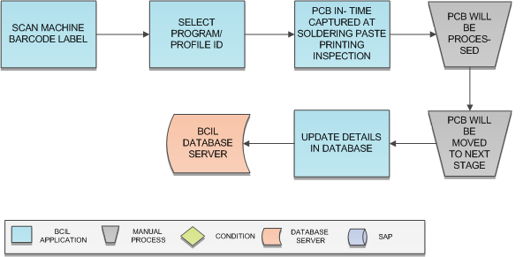

Activities
Module Description | The module will be used to update the process parameters and update the database in database.  *This activity will be performed via Device Application.
Pre-Conditions | - Fixed Mount Scanner (SICK Scanner) should be installed on Conveyor and connected with the application  - Fixed Mount Scanner on conveyor should have scanned PCB on completion (out-time) of previous process.  *Fixed Mount Scanner and Machine Integration at SMT Line needs to be discussed with Cyient Team.  - Reflow Oven should have barcode label.  - PCB should have barcode label and Serial Number.

Process Steps | - User will scan Machine barcode label.  - Select Program/ Profile ID.  - PCB will be processed in Machine.  - Process Parameters will be received from machine in text or CSV file.  - PCB will be moved to next process  - Process details will be updated in database.

Post-Conditions | - On process completion, PCB will be moved out of machine via conveyor.  - Fixed Mount Scanner will capture the PCB Out-Time.  - Out-Time will be updated in database on completion.

Validations | - System will check whether PCB has been processed in previous process.  - System will validate whether PCB In-Time is captured by Fixed Mount Scanner & updated in database.  - In-Time of PCB current process should be same as PCB Out-Time of previous process.  - A file should be provided by Machine containing the process parameters.  - Fixed Mount Scanner should be able to capture the PCB Out-Time on process completion.  - Out-Time of PCB should be updated in database on process completion.

AOI (Automated Inspection)
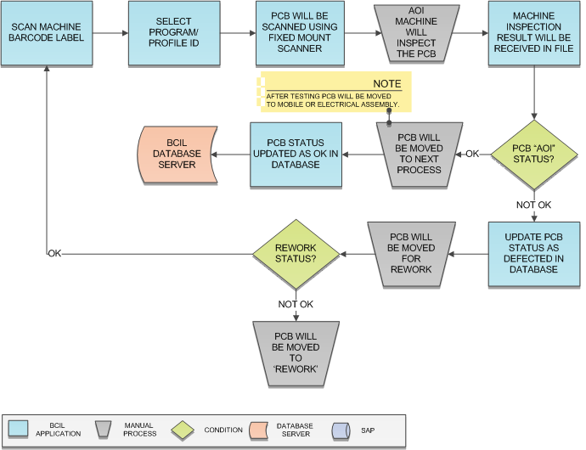

Activities
Module Description | Using this module, user will be able to update the defected PCB status, the components mounted on PCBs will be inspected in AOI Machine and the result for the same will be updated.  *This activity will be performed via Device Application.

Pre-Conditions | - Fixed Mount Scanner (SICK Scanner) should be installed on Conveyor and connected with the application  - Fixed Mount Scanner on conveyor should have scanned PCB on completion (out-time) of previous process.  *Fixed Mount Scanner and Machine Integration at SMT Line needs to be discussed with Cyient Team.  - AOI Machine should have barcode label.  - Machine should be integrated with application.  - PCB should have barcode label and Serial Number.

Process Steps | - Scan Machine barcode label.  - Select Program/ Profile ID.  - PCB will be scanned using Fixed Mount scanner.  - AOI Machine will inspect the PCB components.  - PCB will be scanned on Inspection completion.  - PCB inspection status “Not OK”:  - Defected PCB will be moved for Rework.  - On Rework completion, if PCB “OK” then same AOI process will be followed for PCB.  - Inspection Parameters will be received from machine in text or CSV file.  - Inspection details will be updated in database.

Post-Conditions | - A file should be provided by Machine containing the PCB status  - Accepted/ OK PCBs will be available for Sequencer process.  - Rejected PCB will move for Rework

Validations | - System will check whether PCB previous process has been completed.  - An alert/ error message is displayed in case FMS is not connected with the application  - AOI Machine should notify the defected PCB.  - User should scan only the defected PCB in case PCB status is “Not OK”.

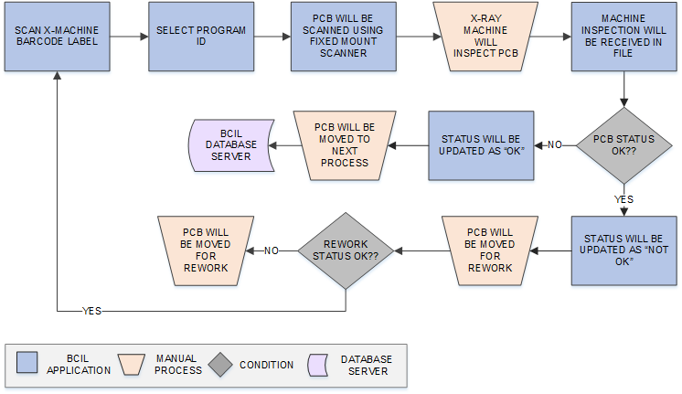
X Ray Machine Inspection
Activities
Module Description | In this process, Items will pass through X-Ray machine and inspected; PCB Status will be updated as OK/ Not Ok. OK PCBs will move at Assembly Line whereas rejected PCBs will go for Rework details updated in database.  *This activity will be performed via Device Application.

Pre-Conditions | - Fixed Mount Scanner (SICK Scanner) should be installed on Conveyor and connected with the application  - Fixed Mount Scanner on conveyor should have scanned PCB on completion (out-time) of previous process.  *Fixed Mount Scanner and Machine Integration at SMT Line needs to be discussed with Cyient Team.  - X Ray Machine should have barcode label.  - Machine should be integrated with application.  - PCB should have barcode label and Serial Number.

Process Steps | - Scan Machine barcode label.  - Select Program/ Profile ID.  - PCB will be scanned using Fixed Mount Scanner.  - X-Ray Machine will inspect the PCB.  - PCB will be scanned on Inspection completion.  - PCB inspection status “Not OK”:  - OK PCBs will move for Assembly.  - PCB inspection status “Not OK”:  - Defected PCB will be moved for Rework.  - On Rework completion, if PCB “OK” then same X-Ray process will be followed for PCB.  - Inspection details will be updated in database.

Post-Conditions | - Accepted/ OK PCBs will be available for Assembly process.  - Rejected PCB will move for Rework

Validations | - System will check whether PCB previous process has been completed.  - An alert/ error message is displayed in case FMS is not connected with the application  - An error/ alert will be displayed in case of any invalid activity.

Rework
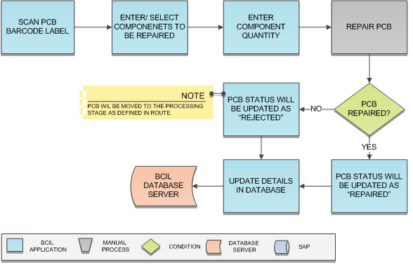

Activities
Module Description | In this process, items rejected from quality stage will be received (repair-in) and repaired. Defected item’s component will be replaced with new component and details updated in database.  *This activity will be performed via Device Application.

Pre-Conditions | - PCB should have barcode label and Serial Number.  - Route details should be maintained in Route Master.

Process Steps | - Receive rejected item at repair stage.  - Scan PCB barcode label.  - Enter/ select Component to be used in repairing.  - Enter Component’s quantity to be used.  - If PCB is repaired, move the PCB to processing stage as per the route defined in Route Master.  - Update details in database.

Post-Conditions | - Repaired PCBs will be send back to the processing stage, PCB will move as per the defined route in the Route Master.

Validations | - System will validate input data i.e. text field values and selections.  - An alert message is displayed in case of any error / invalid activity.  - System will display alert message in case duplicate / invalid barcode is being scanned.

WIP Operations-Assembly Line

Process at a Glance

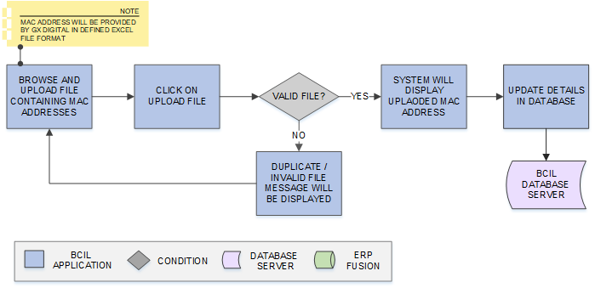
Model Wise MAC ID Upload
Activities
Module Description | This module will be used to import the excel file containing MAC Address for Mobile device and save corresponding details in database. The file will contain MAC Address, GPON Serial No., BOSA Number.  *This activity will be performed via Web Application.

Pre-Conditions | - MAC Addresses should be saved in defined excel file format.

Process Steps | - User will login into web application and open Model Wise MAC ID Upload module  - Browse file containing Mac Addresses  - Select and Import file in defined file format.  - Click on Upload  - System will validate the selected file and details will appear on screen  - Update details in database.

Post Conditions | - MAC-IDs will be mapped with Production Order via Mapping module

Validations | - An alert will be displayed in case file is not uploaded.  - An alert will be displayed in case duplicate data is being uploaded.  - An error message will be displayed in case invalid file is uploaded.

File Format
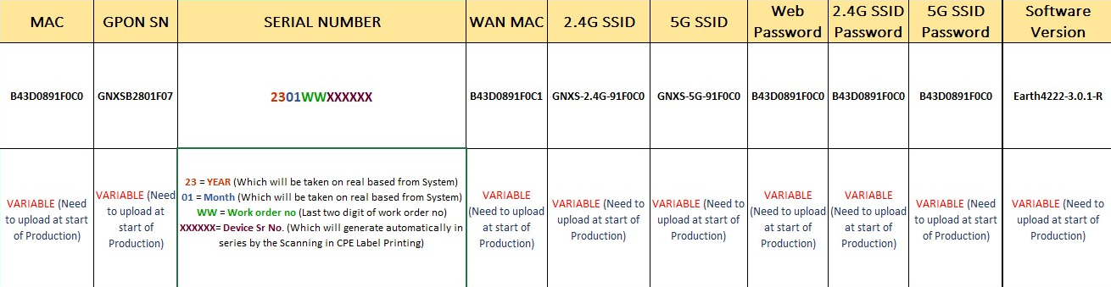
- Cyient Team has shared the file format and MAC Addresses to be uploaded which is as shown:

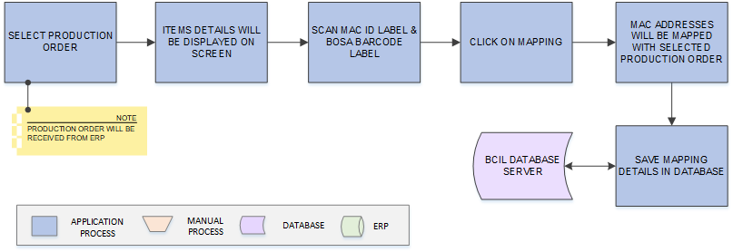
Mac ID-Production Order Mapping
Activities
Module Description | This module will let allow user to scan and map the MAC Address with Production Order selected at Line and corresponding details will be updated in database.  *This activity will be performed via Device Application.

Pre Conditions | - Scheduler application should be running in background to download Production Order.  - MAC Addresses should have been uploaded  - Item should have pre-printed MAC labels & BOSA barcode label

Process Steps | - Select Production Order  - Item details against Production Order will appear on screen.  - Scan MAC ID & BOSA Barcode label  - Click on Mapping.  - System will validate the scanned labels  - Update mapping details in database.

Post Conditions | - Transaction details will be saved in database.

Validations | - An alert will be displayed in case Production Order is not available.  - System will validate input data i.e. text field values and selections.  - An alert will be displayed in case duplicate/ invalid barcode is scanned.

RF Testing Calibration
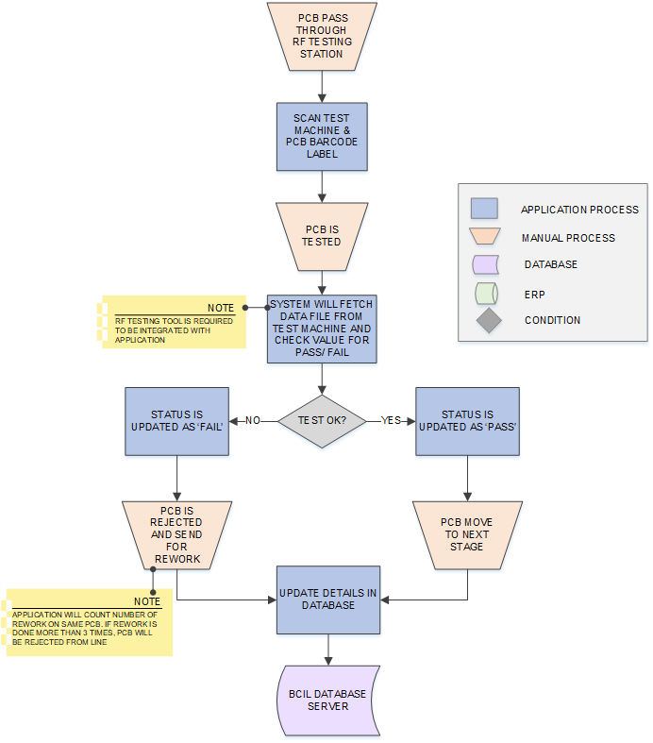

Activities
Module Description | The module will be used to test the product through RF testing tools. At RF testing stage, existing Cyient System will run script and pass Serial Number (MAC Address and Stage Code) and test result for PCB to BCI application. If test result is pass, Product will move to next process else send for rework. If rework is done more than 3 times on same Product, it will be rejected from the Line.  Integration with existing Cyient System will be required to pass the Script data.  *This activity will be performed via Web Application & API Interface.

Pre Conditions | - API Integration is required with existing Cyient System.  - PCB should have MAC and BOS Barcode label.  - RF Testing tool should be integrated with application.  - Device should be available

Process Steps | - Scan PCB in existing Cyient System.  - Cyient System will run a Script and pass Serial Number of the scanned PCB to BCI Application  - BCI Application will read Serial Number (MAC Id and Stage Code) and pass OK/ NOT OK to Cyient system  - If RF Testing result is OK  - Script will write/ test PCB  - Popup message will display previous stage result of PCB  - CP Labels will be printed for OK PCBs  *Please refer to 8.7.5 CP Label Printing module for this activity.  - If RF Testing result is Not OK:  - Send PCB for rework  - Enter reason  *BCI Application will count number of times rework is done on same PCB. If rework is done more than 3 times, PCB will be rejected from Line  - Update testing details in the database.

Post Conditions | - Testing details will be saved in database.  - PCB on which rework is done more than 3 times will be rejected from Line.  - CP Labels will be printed for OK PCBs.  *Please refer to 8.7.5 CP Label Printing for this activity.

Validations | - System will validate the scanned PCB.  - An alert will be displayed in case duplicate/ invalid barcode is scanned.  - Cyient API Interface should provide the test result to BCI Interface.

CPE Label Printing
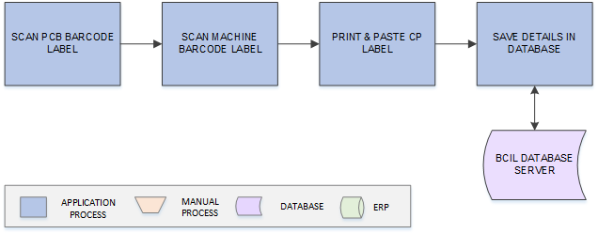

Activities
Module Description | This module will help user to print CPE Labels for OK PCBs and update corresponding details in database.  *This activity will be performed via Device Application.

Pre Conditions | - PCB should have passed RF Testing.  - Machine should have barcode label  - PCB should have barcode label  - Device should be available  - Printer should be connected with the application.

Process Steps | - Scan Machine Barcode Label  - Scan PCB barcode label.  - Print label for PCB.  - Paste label on PCBs.  - Update details in database.

Post Conditions | - PCBs mill move for further testing at multiple machines.

Validations | - System will validate the scanned PCB and Machine.  - An alert will be displayed in case duplicate/ invalid barcode is scanned.  - An alert should be displayed in case label is not printed or printer is not connected.

CPE Sample Label Design | - CPE Sample Label Design is provided by Cyient Team and will be as shown:  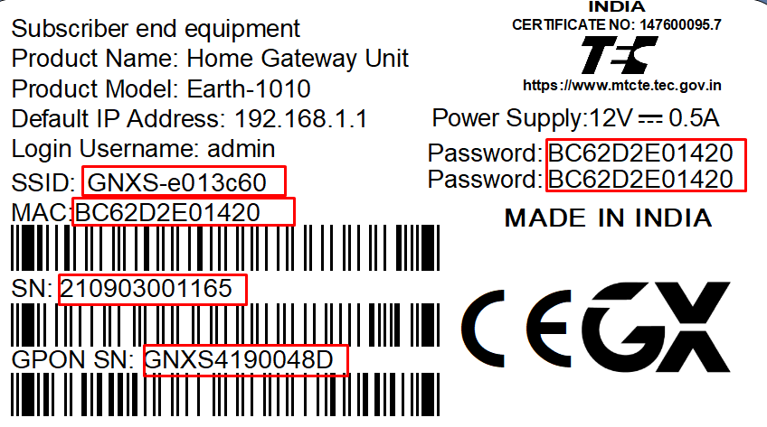

Testing- BOB, Functional, Flow, Optical/ Final Test Calibration
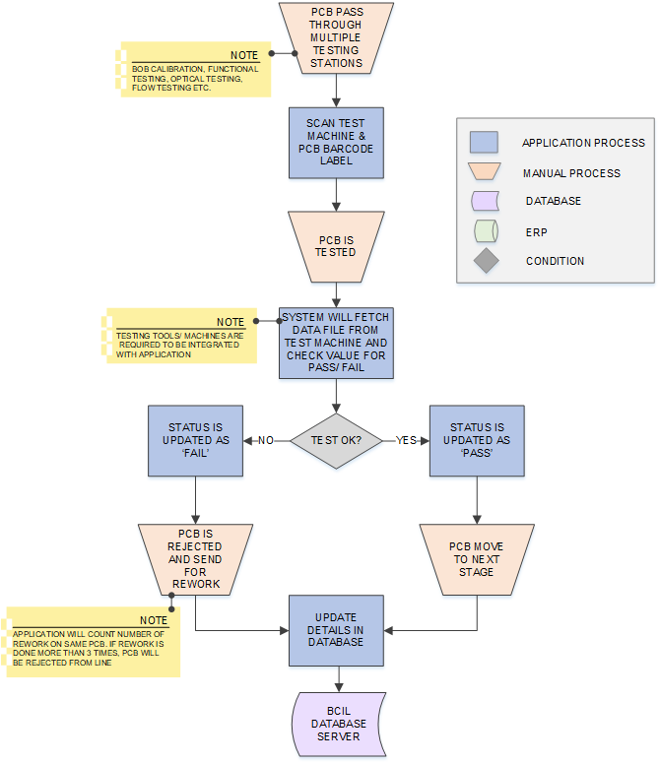

Activities
Module Description | The module will be used to test the product through multiple testing tools and machines. At each testing stage, existing Cyient System will run script and pass Serial Number and test result for PCB to BCI application. If test result is pass, Product will move to next process else send for rework. If rework is done more than 3 times on same Product, it will be rejected.  Integration with existing Cyient System will be required to pass the Script data.  *This activity will be performed via Web Application & API Interface.
Pre Conditions | - CP Label should have been printed.  - API Integration is required with existing Cyient System.  - Multiple Testing tools/ Machines (i.e. BOB Tool, Functional, Flow and Optical machines) should be integrated with application.  - Device should be available

Process Steps | - Scan PCB in existing Cyient System.  - Cyient System will run a Script and pass Serial Number of the scanned PCB to BCI Application  - BCI Application will read Serial Number (MAC Id and Stage Code) and pass OK/ NOT OK to Cyient system  - If Result is OK:  - Script will write/ test PCB  - Popup message will display previous stage result of PCB  - If Result is NOT OK:  - Send PCB for rework  - Enter Reason  - On process completion (all 4 stages), Cyient will pass OK/ NOT Ok result to BCI  - If OK:  - BCI application will update PCB result as OK  - Move PCB to next process  - If NOT OK:  - Repeat step 5  - Application will count number of times rework is done on same PCB  - If rework is done more than 3 times, Reject PCB  - Update testing details in the database.

Post Conditions | - Testing details will be saved in database.  - PCB on which rework is done more than 3 times (on any of the Machine) will be rejected from Line.  - OK Product will move for primary packing.  *Please refer to 8.6.7 Gift Box Label Printing for this activity.

Validations | - System will validate the scanned PCB.  - An alert will be displayed in case duplicate/ invalid barcode is scanned.  - Cyient API Interface should provide the test result to BCI Interface.  - PCB on which rework is done more than 3 times should not be sent for further process.

Machine Codes:
Machine Codes | Machine/ Test Name
T1 | RF Test
T2 | BOB Test
T3 | Function Test
T4 | Flow Test
T5 | Final Test (NFT+ Check)

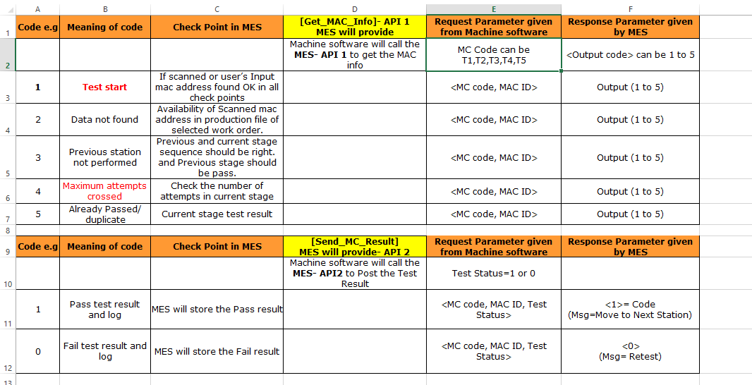
MES and Test API Call Flow Details

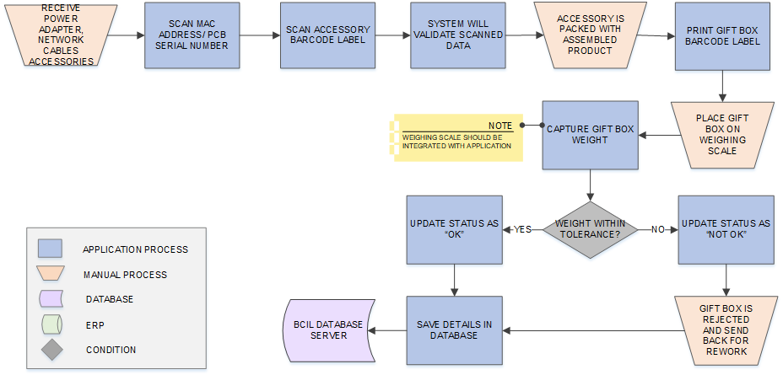
Gift Box Label Printing

Activities
Module Description | In this process, Assembled Product will be packed in Gift Box along with the accessories (Power Adapter, Network Cable etc.). Barcode Label will be printed for the Gift Box in order to uniquely identify each Gift Box. Each Gift Box is weighed and tolerance is validated from master data. If weight is not within defined tolerance, then Gift Box is rejected and send for rework.  *This activity will be performed via Device Application.

Pre Conditions | - Power Adapter, Network Cable etc. accessories should be received  - Items should have barcode label  - Device should be available  - Weighing Scale should be integrated with BCI application.  - Printer should be connected with the application.

Process Steps | - Receive Power Adapter, Network Cable etc. accessories.  - Scan PCB/ Mac Address Label and Accessories Label.  - Pick and place scanned items in Gift Box  - Print Gift Box label  - Place Gift Box on weighing scale  - Weigh and capture Box weight.  *Weighing scale is required to be integrated with the application.  - If Weight is within defined weight tolerance:  - Status is updated as OK  - Move Box for next process  - If Weight is NOT within defined weight tolerance:  - Alert message is displayed  - Status is updated as NOT OK  - Box gets rejected  - Send Box for rework.  - Update details in the database.

Post Conditions | - Not Ok Boxes will be sent for rework  - Ok Primary Packs/ Gift Boxes will move for Secondary Packing/ Carton Packing.  *Please refer to 8.6.8 Carton Label Printing for this activity.

Validations | - An alert should be displayed in case Weighing Scale is not integrated with the application  - An error message should be displayed in case captured weight is not within defined weight tolerance and label should not be printed.  - An alert should be displayed in case duplicate/ invalid barcode is scanned.  - An alert should be displayed in case label is not printed or printer is not connected.

Gift Box Sample Label Design | - Gift Box Sample Label Design is provided by Cyient Team and will be as shown:  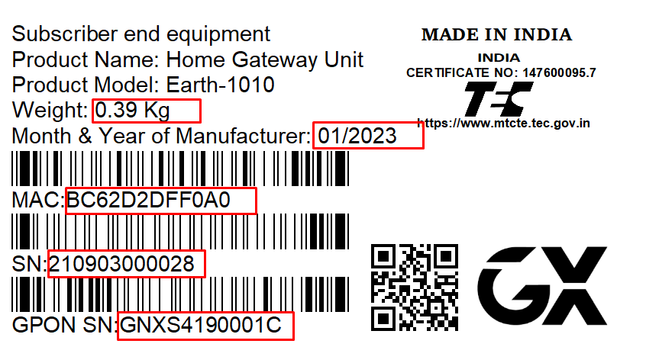

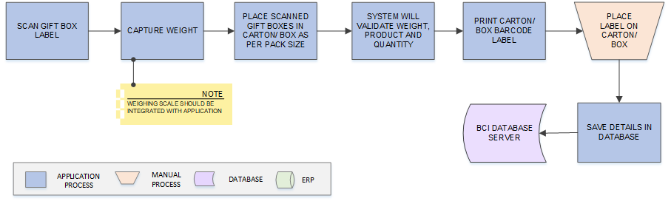
Carton Label Printing
Activities
Module Description | In this process, Gift Boxes will be placed in a Carton as per pack size and label will be printed for the same. System will ensure that right Product and correct number of boxes shall be packed in Shipping Box.  *This activity will be performed via Device Application.

Pre Conditions | - Item should be packed in Gift Box and printing should have been done.  - Device should be available  - Weighing Scale should be integrated with BCI application.  - Printer should be connected with the application.

Process Steps | - Scan Gift Box Barcode Label.  - Capture weight  - User will place scanned Gift Boxes in Carton/ Box as per pack size.  - System will validate the weight, product and quantity  - Print Carton Barcode Label.  - User will paste Barcode Label on Carton.  - Move Carton for Final QC.  - Update packing details in the database.

Post Conditions | - Not Ok Cartons will be sent for rework  - Ok Cartons will move for Final QC.  *Please refer to 8.6.9 Final Quality Check for this activity.
Validations | - An alert should be displayed in case Weighing Scale is not integrated with the application  - An error message should be displayed in case captured weight is not within defined weight tolerance and label should not be printed.  - System will validate that the Gift Box is packed as per the defined Packsize.  - An alert should be displayed in case duplicate/ invalid barcode is scanned.  - An alert should be displayed in case label is not printed or printer is not connected.

Carton Sample Label Design | - Master Box QR Code Creation: QR code will consist MAC address, GPON Serial Number and Box no.  - Carton Box ID Creation  - Carton/ Box Sample Label Design is provided by Cyient Team and will be as shown:  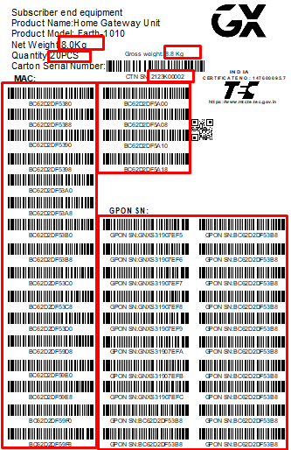

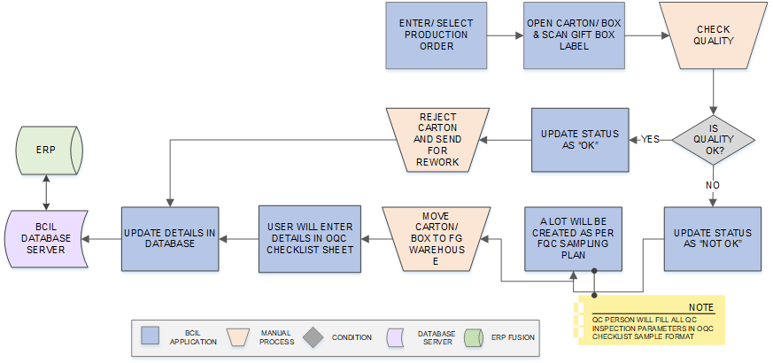
Final Quality Check (FGQC)
Activities
Module Description | In this process, Quality of Product in Carton is checked and if any defect / damage is found then product will be rejected and send for rework. OK Cartons will move to FG Warehouse.  *This activity will be performed via Device Application.

Pre Conditions | - SFG/ FG Cartons should be received.  - Cartons should have barcode label.  - Device should be available  - FQC Sampling Plan should be created and maintained in Sampling Master.

Process Steps | - Select Production Order Number  - Pick Carton.  - Open Carton/ box and scan Gift Box label  - Check quality  - If quality is OK:  - Status is updated as OK  - A lot will be created for scanned Cartons as per FQC Sampling Plan.  *QC person will fill all the QC inspection parameters in OQC Checklist Sample format.  - SFG Carton/ Box is moved to FG Warehouse.  - If quality is NOT OK:  - Status is updated as NOT OK  - Carton/ Box is rejected and move for rework  - Update details in the database.

Post Conditions | - Not Ok Cartons will be sent for rework  - Ok Cartons will move to FG Warehouse.  - A lot will be created for scanned Cartons as per FQC Sampling Plan  - FG QC needs to be confirmed in SAP.

Validations | - An alert should be displayed in case duplicate/ invalid barcode is scanned.  - An alert/ error should be displayed in case of any invalid activity.

OQC Checklist format to be filled during FG QC:
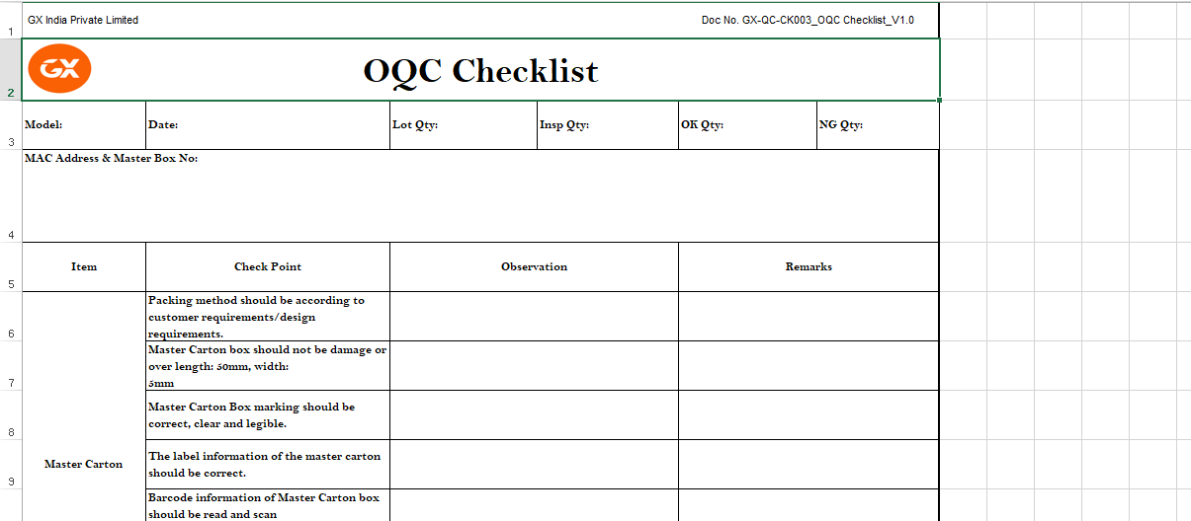
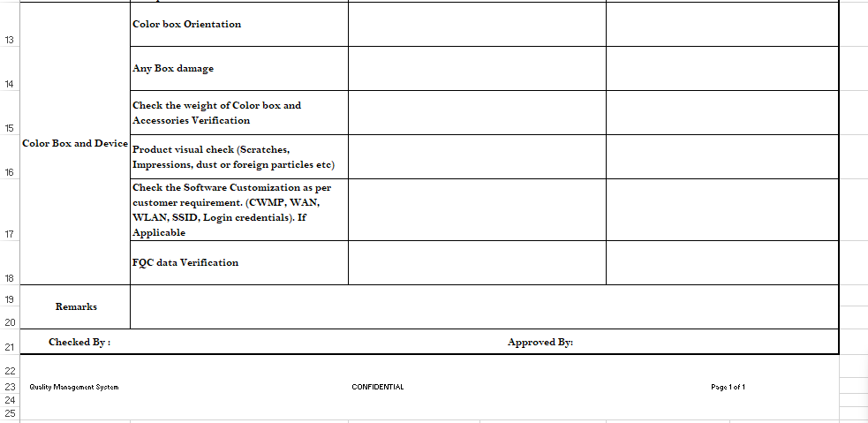
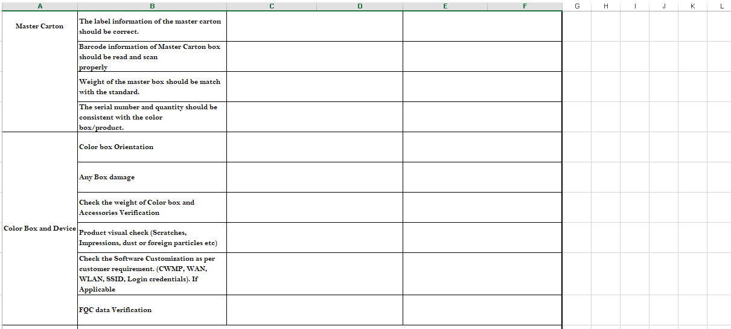

Bin Replenishment
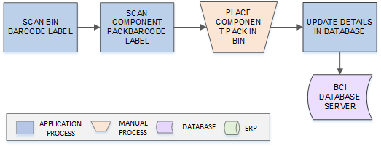

Activities
Module Description | This module will be used to map RM Components with the Bins and details are saved in database. This will help in validating data at the time of Bin issuance to Shop Floor.  *This activity will be performed via Device Application.

Process Steps | - Scan Bin Barcode Label.  - Scan Component Pack Barcode Label.  - User will place Component pack in scanned Bin.  - Update Bin – Component mapping details in the database.

FG Warehouse Operations

Process at a Glance

Putaway
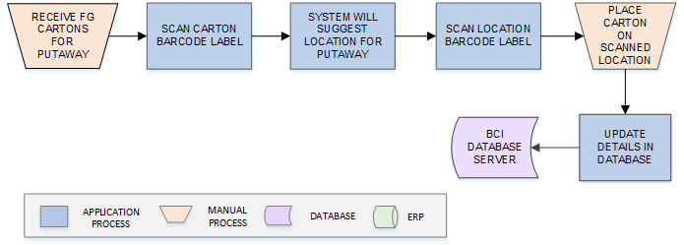
Activities
Module Description | This module will let user to scan and place FG Cartons on storage location, and update the location-item mapping details in database.  *This activity will be performed via Device Application.

Pre-Conditions | - FG Cartons should have barcode label.  - FG QC has been done.  - Location should have barcode label.  - HHT Device should be available.

Process Steps | - Receive FG Carton.  - Scan Carton Barcode label  - Scan Location Barcode label  - Place FG Cartons at scanned location  - Update details in the database.

Post-Conditions | - Location-material mapping details should get updated in database.

Validations | - An alert should be displayed in case invalid/ duplicate Carton barcode is scanned.  - An alert should be displayed in case invalid/ duplicate Location barcode is scanned.

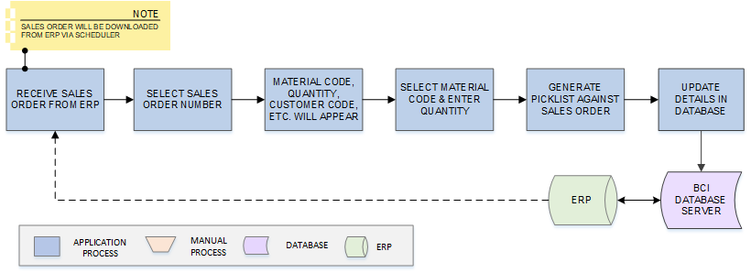
Picklist Generation
Activities
Module Description | This module will let user to create Delivery Picklist against Sales Order downloaded from SAP; corresponding details will be saved in database. Multiple Delivery Picklists can be generated against a single Sales Order.  *This activity will be performed via Web Application.

Pre-Conditions | - Carton should have barcode label.  - Scheduler application should be running in background to download Sales Order.

Process Steps | - Receive Sales Order from SAP.  - Select Sales Order.  - Material Code, Quantity, Customer Code, Customer Name, etc. will appear on screen.  - Select Material Code.  - Enter Quantity.  - Generate Delivery Picklist against Sales Order.  *Multiple Delivery Picklists can be generated against a single Sales Order.  - Update details in the database.

Post Conditions | - Delivery Picklist should be available at the time of Picking.

Validations | - System will validate input data i.e. text field values and selections.  - An alert message is displayed in case of any error / invalid activity.  - Each Picklist will have unique reference number.

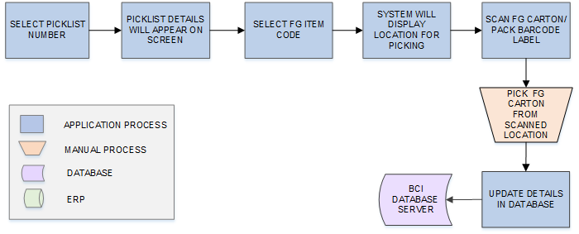
Picking
Activities
Module Description | This module will help user to pick Cartons (FG material) against Delivery Picklist from suggested locations and update corresponding details in database.  *This activity will be performed via Device Application.

Pre-Conditions | - Picklist should be available.  - HHT device should be available.

Process Steps | - Select Picklist Number in HHT.  - Picklist details will appear on screen.  - User will select Item Code.  - System will display the Location for selected Items in FIFO Order.  - User will scan Location barcode label.  - Scan FG Pack barcode label.  - Pick FG Cartons/ Packs against Picklist.  - Update picking details in database.

Post Conditions | - Picking details will get saved in database  - Picked Carton/ Items will move for PDI Inspection.

Validations | - System will display locations in FIFO order to pick items.  - FG Cartons will be validated against Picklist.  - System will display alert message in case duplicate / invalid barcode is being scanned.

PDI Inspection
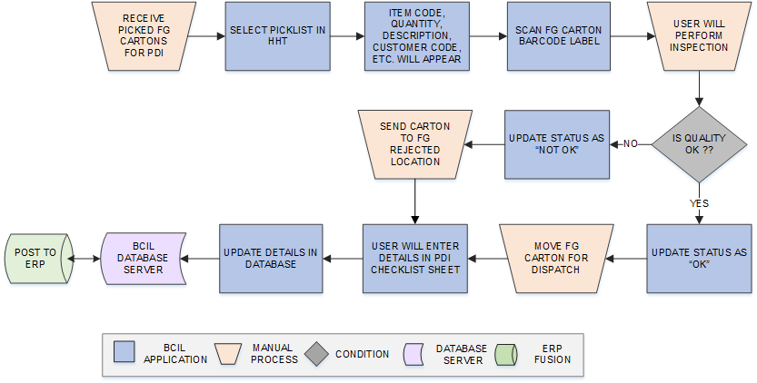
Activities
Module Description | This module will let user to check quality of picked FG Cartons and if any defect / damage is found then Carton will be sent to rejected location and OK Cartons will be loaded for dispatch.  *This activity will be performed via Device Application.

Pre-Conditions | - Carton/ Item picking should have been done.  - Delivery Picklist should be available.  - HHT device should be available.

Process Steps | - Select Delivery Picklist Number in HHT.  - Material Code, Quantity, Customer Code, Customer Name, etc. will appear on screen.  - Scan FG Carton Barcode label.  - User will Inspect the Cartons against Picklist  - Inspection Result is OK:  - Update Status as “OK”  - Move Carton for Dispatch.  - Inspection Result is Not OK:  - Update Status as “Not OK”  - Send Carton to FG rejected location.  - User will enter checklist details in PDI Checklist Sheet.  - Update details in the database.  - Post details to SAP.

Post Conditions | - Ok Cartons will move for Dispatch.  - Not Ok Cartons will be sent to FG Rejected location  - PDI Inspection confirmation will be posted to SAP.

Validations | - System will validate input data i.e. text field values and selections.  - An alert message is displayed in case of any error / invalid activity.  - System will validate FG barcode and display error in case of invalid or duplicate barcode is scanned.
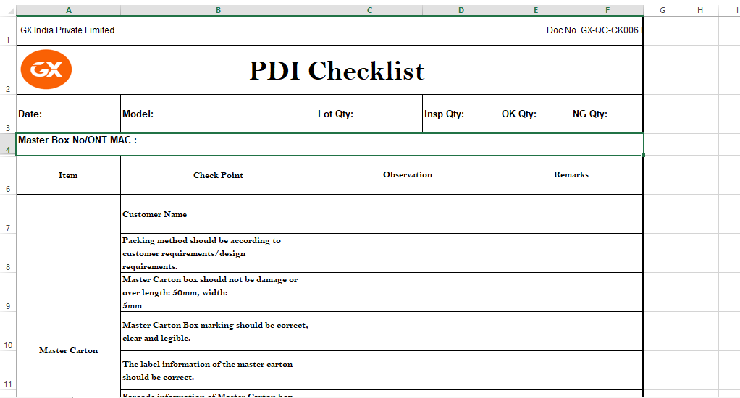
PDI Checklist to be filled:

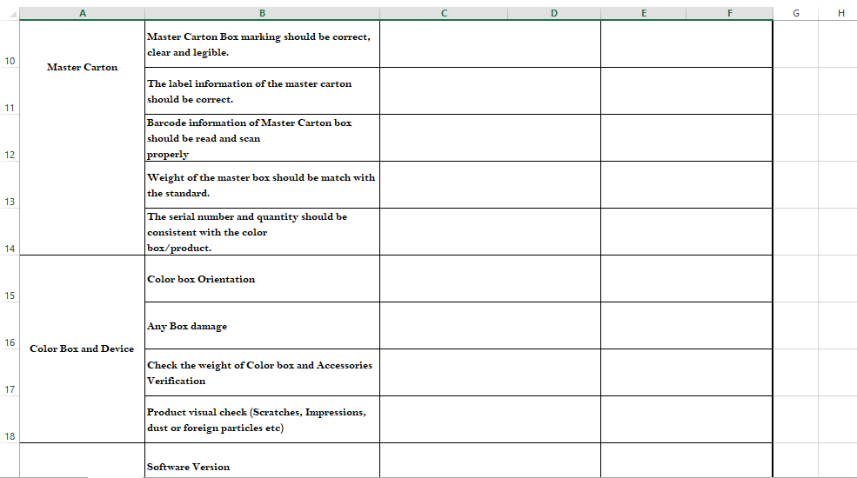

Loading & Dispatch
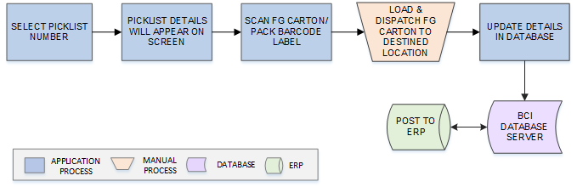
Activities
Module Description | This module will allow user to scan and dispatch FG Cartons against Delivery Picklist and update corresponding details in database  *This activity will be performed via Device Application.

Pre-Conditions | - Delivery Picklist should be available.  - Invoice no should be generated in the SAP against Delivery Picklist.  - Carton/ Item should have barcode label  - HHT device should be available.

Process Steps | - Select Delivery Picklist Number in HHT.  - Material Code, Quantity, Customer Code, Customer Name, etc. will appear on screen.  - Scan Carton Barcode label.  - Load and dispatch FG Cartons to destination.  - Update details in the database.
Post Conditions | - Ok Cartons will move for Dispatch.  - Not Ok Cartons will be sent to FG Rejected location  - PDI Inspection confirmation will be posted to SAP.
Validations | - System will validate input data i.e. text field values and selections.  - An alert message is displayed in case of any error / invalid activity.  - System will validate FG barcode against Delivery Picklist  - An error/ alert will be displayed in case invalid or duplicate barcode is scanned.

Sales Return
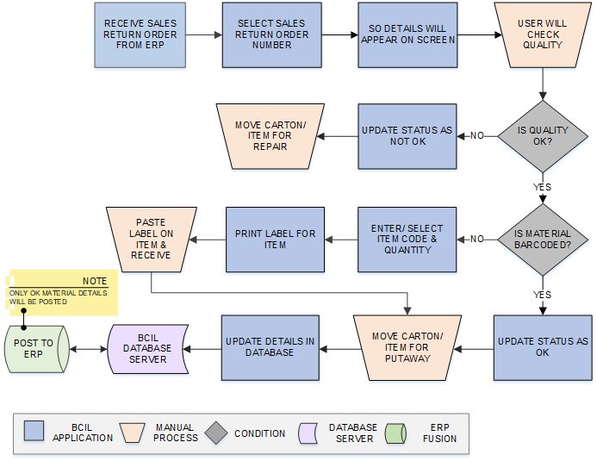
Activities
Module Description | The module will help user to update the details of Items returned against the Sales Return Order. The Sales Return Number will be received from SAP, against the reference of which user will update the returned Items details.  *This activity will be performed via Device Application.

Pre-Conditions | - Scheduler application should be running in background in order to download Sales Order from SAP.  - Carton/ Item should have barcode label  - HHT device should be available.

Process Steps | - Receive Sales Return Order from SAP.  - Select Sales Return Order Number in HHT.  - Item Code, Quantity, Customer Code, Date, Invoice Number, etc. will appear on screen.  - User will check Quality.  - If Quality is “OK”:  - If Material received is Barcoded:  - Scan Item Barcode Label.  - Update Status as “OK”.  - If Material received is Non Barcoded:  - Select Item Code  - Enter Quantity.  - Print & Paste label on Item.  - Update Status as “Ok”.  - Move Item for Putaway.  *Refer 8.8.2 Putaway module for this activity  - If Quality is Not OK:  - Update Status as “Not Ok”.  - Move Carton/ Item for Repair  - Update details in the database.

Post Conditions | - Ok Carton/ Item will move for Putaway.  - Not Ok Carton/ Item will be sent for Repair.  - Stock details for OK Item will be posted in SAP.

Validations | - System will validate input data i.e. text field values and selections.  - An alert message is displayed in case Scheduler is unable to fetch Sales Order from SAP.  - An error/ alert will be displayed in case invalid or duplicate barcode is scanned.

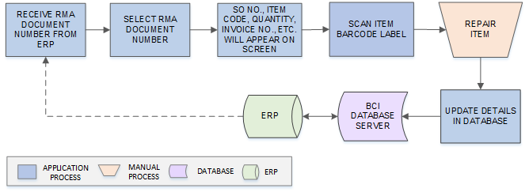
RMA Repair
Activities
Module Description | The module will allow user to repair the sales returned item against RMA Document Number received from SAP and update the corresponding details in database.  *This activity will be performed via Web Application.

Pre-Conditions | - Scheduler application should be running in background in order to download RMA Document from SAP.  - Item for Repair should be received.

Process Steps | - Receive RMA Document from SAP.  - Item Code, Quantity, Customer Code, Sales Order Number, Invoice Number, etc. will appear on screen.  - Repair Item.  - Update details in the database.

Post Conditions | - Details will be updated in database.

Validations | - System will validate input data i.e. text field values and selections.  - An alert message is displayed in case Scheduler is unable to fetch RMA Document from SAP.  - An error/ alert will be displayed in case of any invalid activity.

Internal Movement
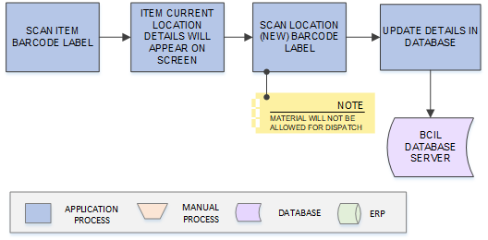

Activities
Module Description | The module will allow user to move the material from one location to another location and update the corresponding details in database. Moved material moved to temporary firmware location will not be allowed to dispatch.  *This activity will be performed via Web Application.

Pre-Conditions | - Item should have barcode label

Process Steps | - Scan Item, item location will appear on screen  - Scan New Location barcode label.  - Update mapping details in the database.

Post Conditions | - Details will be updated in database.  - Material will not be allowed for Dispatch.

Validations | - System will validate input data i.e. text field values and selections.  - An alert message is displayed in case invalid/ duplicate barcode is scanned.  - An error/ alert will be displayed in case of any invalid activity.

Firmware Upgradation
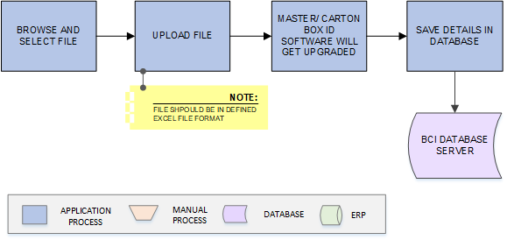

Activities
Module Description | The module will allow user to update the Software Versions of Master/ Carton Box by manually uploading the firmware upgradation data ( fields like MAC/Carton Barcode, Firmware Ver.) in application  *This activity will be performed via Web Application.

Pre-Conditions | - Details should be saved in defined file format

Process Steps | - Browse and upload File.  - Uploaded details will appear on screen  - Save details in the database.

Validations | - System will validate input data i.e. text field values and selections.  - An alert message is displayed in case invalid/ duplicate file is uploaded.  - An error/ alert will be displayed in case of any invalid activity.

File Format for Upgraded Tracking Material Data Upload
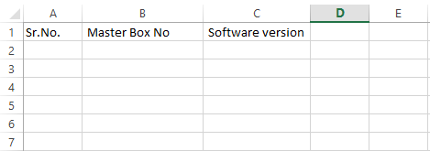

Reports
Reporting module will provide access to the data that will be helpful in making well-informed strategic decisions, reduces risk, and increases productivity. The reporting interface will be user-friendly, application users can easily generate, and view required data.
The application will generate customized reports based on required data fields and time interval selected / entered by users; Microsoft Crystal Reports/ RDLC Reports will be generated which can be exported into defined standard excel file/ PDF format as and when required.
Reports can be defined as private for restricted viewing – or made public, giving access to information based on access rights assigned to the particular user / group.
*8-10 Customized Reports will be provided.

Points discussed during SRS review on 21 March 2023.

- TSC MB341- 300dpi Ethernet Printer will be used for RM Stores Label printing
- Sample FG trial run for 5 PCBs is required for the Assembly line only with the Verification MAC and Scanning stage.
- Offline checksheet format report printing option.
- Running serial no reset on Year basis for all offline cheklist sample on every record. Doc name( FAI-23-0001)
- Separate work order will be provided for SMT and Assembly.
- SMT- SFG item label printing with Identification of SFG similar to the RM process.
- Vendor code variable to be added in RM label
- Work order selection is required with the production order on the SMT/Assembly Production line
- Serial no will be generated and printed with MES on CPE label.
- Work order will be added as an parameter in the Machine File integration input /output parameters.
- Laser printer( export print data into file for read by laser mc) + offline Lan based printer (optional required).
- RMA is not required only sales return is required.

SAP Integration Touch Points
SAP Integration Touch Points:
- Item BOM- [Get from Hana]
Input parameters: Site Code, Item Code (can be null), date time stamp
Output data fields: Site Code, FG Item code, Item Code, Item Description, Item Type (SFG/RM), Item UOM, Item Qty, Make, MPN
- Location Master- [Get from Hana]
Input parameters: Site Code, Location Type (can be null)
Output data fields. Site Code, SAP Storage Location, Location Type, Location Name
Example:
SAP Storage Location Code | Location Type | Location Name
? | RM | Temporary Under Quality/OK/Reject/Hold/Scrap/Shortage/Rework
? | WIP | Temporary Under Quality/OK/Reject/Hold/Scrap/Shortage/Rework/TRC-Repair
? | FG | Temporary Under Quality/OK/Reject/Hold/Scrap/Shortage/Rework/TRC-Repair

- GRN Download from the SAP- [Get from Hana]
Input parameters: Site Code, Last date time stamp (SAP will send the available GRN created after time stamp sent in the input parameter)
Output data fields: Site Code, GRN No, GRN Date, Supplier Code, Supplier Name, Batch no, PO number, Item Code, Item Line no, Item Qty, MFG date, Expiry Date
- RM QC posting –[Post to SAP)
Input data fields: Site Code, GRN no, Batch no, item code, qty
Example:
GRN no, Batch no, item code, qty- OK only
GRN no, Batch no, item code, qty- Reject only
(Separate line items for Ok and Reject qty)
Output data fields: Site Code, GRN no, Batch no, item code, qty, Status ( Success/Fail)
- Work Order download- RM to Shop Floor Issuance- [Get from SAP]
Input parameters: Site Code, Last time stamp
Output data fields:
- Work Order(Header)- Site Code, Work order No, Word Order date, Item Code, Plan Qty
Work Order BOM- Site Code, Work order No, Word Order date, FG Item code, Item Code, Item Description, Item Type(SFG/RM) Item UOM, Actual Item Qty
- RM to Shop floor Stock transfer- [Post to SAP]
- SFG return from shop floor to RM Store- [Post to SAP]
- Excess RM return from Shop floor to RM Store [Post to SAP]
Input data fields: Site Code, Work order No, Word Order date, FG Item code, Item Code, Item Description, Actual Item Qty, Issued Qty, Flag ( 1= RM issuance, 2= SFG Return, 3= excess RM stock return)
Output data fields: Site Code, Work order No, Word Order date, FG Item code, Item Code, Item Description, Actual Item Qty, Issued Qty, Flag, Status ( Success/Fail)
- Goods issuance download- Extra material issuance RM to Shop Floor [Get From SAP]
Input parameters: Site Code, Last time stamp
Output data fields: Site Code, Issue Slip No, Issue Slip date, Item Code, Item Description, Item UOM, Actual Item Qty
- Goods issuance Stock Transfer- RM to Shop Floor ( Post to SAP]
Input data fields: Site Code, Issue Slip No, Issue Slip date, Item Code, Item Description, Item UOM, Actual Item Qty, Issued Qty
Output data fields: Issue Slip No, Issue Slip date, Item Code, Item Description, Item UOM, Actual Item Qty, Issued Qty, Status (Success/Fail)
(Repair TRC location transfer will be done using Goods issuance)
- Supplier Return RM [Get from SAP]
- RM -JOB work Process [Get from SAP]
Input parameters: Site Code, Last time stamp
Output data fields: Site Code, Requisition Slip No, Requisition Slip date, Supplier/Vendor Code, Item Code, ItemLineno, Plan Qty, Flag (1= Supplier Return, 2= JOB work)
- Work Order FG/SFG confirmation – [Post to the Hana]
Input data fields: Site Code, Work order No, Word Order date, FG Item code, Item Code, Item Description, Production Qty, QC Status (OK)
Output data fields: Site Code, Work order No, Word Order date, FG Item code, Item Code, Item Description, Production Qty, QC Status (OK), Status ( Success/Fail)
*Posting will happen only for OK -FG/SFG with Box ID serial no
- Download Sales Order- [Get from Hana]
Input parameters: Site Code, Last time stamp
Output data fields: Site Code, Sales Order No, Sales Order date, Customer Code, Customer Name, Customer Address, Customer City, Customer State, Item Code, ItemLineno, Item MRP, Plan Qty.
- Delivery Picklist Confirmation - [Post to Hana]
Input data fields: Site Code, Sales Order No, Sales Order date, Customer Code, Delivery Picklist No, Item Code, ItemLineno, Delivery Picklist date, Item MRP, Picking Qty, Picked Qty, Box ID, Box ID serial no.
Output data fields: Site Code, Sales Order No, Sales Order date, Customer Code, Delivery Picklist No, Item Code, ItemLineno, Delivery Picklist date, Item MRP, Picking Qty, Picked Qty, Status (Success/Fail)
- Download Delivery Picklist Invoice-[Get from Hana]
Input data fields: Site Code, Delivery Pick list No
Output data fields: Site Code, Delivery Picklist No, Invoice No
- Download Physical Inventory-[Get from Hana]
Input parameters: Site Code, Item Code, Stock Type (RM/WIP/FG), Date & Time Stamp
(Item code can be single and list of items. If item code is null then complete item stock needs to be downloaded)
Output data fields: Site Code, Item Code, Stock Type, Physical Stock Qty
**In case of FG stock- Serial no will be downloaded
- Stock Adjustment-[Post to SAP]
Input parameters: Site Code, Item Code, Stock Type(RM/WIP/FG), Physical Stock Qty
Output data fields: Site Code, Item Code, Stock Type, Physical Stock Qty, Status ( Success/Fail)
- Sales Return- [Get from SAP]- TBD?
Input parameters: Site Code, Last time stamp
Output data fields: Site Code, Sales Return Order No, Sales Return date, Customer Code, Customer Name, Sales Order no, Invoice No, Item MRP, Item Code, ItemLineno, Item Qty, warrenty days.
- Sales Return Material Stock Transfer- [Post to SAP]-TBD?
Input data fields: Site Code, Sales Return Order No, Sales Return date, Customer Code, Customer Name, Sales Order no, Invoice No, Item MRP, Item Code, ItemLineno, Item Qty, Box ID, QC Status (Ok Stock Only)
Output data fields: Site Code, Sales Return Order No, Sales Return date, Customer Code, Customer Name, Sales Order no, Invoice No, Item MRP, Item Code, ItemLineno, Item Qty, Box ID, QC Status, Status ( Success/Fail)
- Sales Return (RMA)- [Get from SAP]-TBD?
Input parameters: Site Code, Last time stamp
Output data fields: Site Code, RMA Document No, RMA date, Customer Code, Customer Name, Sales Order no, Invoice No, Item MRP, Item Code, ItemLineno, Item Qty

SRS Scope Change Process

Before Sign Off
Any changes in SRS need to be informed in writing by Cyient Group. It will be incorporated / confirmed only after doing detailed feasibility study by BCI.
- If any change is out of scope then this would be done as a CR post feasibility and priority will be decided based on mutual agreement.
- Once the change is developed , any further change in the same would be considered as a CR

After Sign Off
Any changes in proposed solution after approval of this document by Cyient are subjected to confirmation from BCI, taking feasibility constraints into account. These changes will be incorporated (if any) into the solution only after delivering proposed solution & may be charged as extra.
- Any change in the proposed solution due to customer system design or process will be considered as CR
- Any process which is not mentioned in this document will not be considered as “mutual understanding or default presence or standard practice”.
The changes in proposed solution before & after acceptance will be mutually agreed and duly signed and accepted by Cyient & BCI.

SRS Acceptance
For Cyient Group | For Bar Code India (BCI)
Name: | Name:
Designation: | Designation:
Department: | Department:
Agreed and Accepted by Cyient and Bar Code India

